WHITE COUNTY BOARD OF COMMISSIONERS
MINUTES OF THE PUBLIC HEARING HELD
THURSDAY, JULY 20, 2023 AT 6:00 P.M.
The White County Board of Commissioners held a Public Hearing on Thursday, July 20, 2023 at 6:00 p.m. in the Board Room at the Administration Building. Present for the meeting were Chairman Travis Turner, Commissioner Terry Goodger, Commissioner Lyn Holcomb, Commissioner Craig Bryant, County Manager Billy Pittard, Finance Director Jodi Ligon, and County Clerk Shanda Murphy. Commissioner Nix was not in attendance.
Chairman Turner called the meeting to order.
Ms. Jodi Ligon made a presentation regarding the proposed 2023 millage rate (see attached). This was the first of three public hearings required in order for the Board of Commissioners to maintain the current millage rate of 9.505 – which would be 0.353 mills (or 3.86%) over the rollback millage rate of 9.152 mills.
Following the presentation, Chairman Turner opened the floor for public comment on the proposed 2023 millage rate.
Mr. Larry Freeman – 987 River Road Cleveland, Georgia: He stated that property values had gone up and the presentation showed that the digest had increase 14% and he felt that the additional revenue generated by the increased digest should be adequate to fund the county’s budget.
Carrie Wall – 165 Mountainside Drive Cleveland, Georgia: She stated that property assessments increase every year and people are going to be taxed out of the county. She said it would be nice to know what was going to happen with the millage rate ahead of time. Chairman Turner stated that the county’s budget was adopted in June, many meetings were held regarding the budget prior to adoption, and the budget was based on a 9.505 millage rate – so this information is made known ahead of time. He also encouraged people to appeal their property assessments if they disagree with the assessment, as the Assessor’s Office had advised that they received very few appeals this year.
Antonella Skinner – 254 Stone Cliff Trace Cleveland, Georgia: She stated that her property assessment had increased 50% since she moved here. She has spoken with staff in the Assessor’s Office and is always told that the process is computerized. She encouraged the Board of Commissioners to work in cooperation with the Assessor’s Office and the Board of Education to make sure people are not taxed out of the county.
Todd Wooten – 6699 Duncan Bridge Road Cleveland, Georgia: He stated that we have enough taxes, fancy buildings and lots of employees. He said people are moving here, paying crazy high prices for properties, then causing everyone’s values to increase. He said he wanted to be buried on his own property and was advised by the Planning Office that he would have to pay $325.00 for the process to have this approved on his own property.
Chairman Turner spoke about his own property assessments increasing and again encouraged people to go through the appeals process if they have an issue with the taxable value that has been assigned to their property.
Mr. Pittard spoke about the assessment process and the homestead exemptions available to property owners.
Chairman Turner had to leave the meeting, due to a prior commitment. He turned the meeting over to Vice-Chair Commissioner Bryant.
Commissioner Bryant displayed the following slide and emphasized that the Board of Commissioners have been very frugal with the county funds, providing all the services needed, and maintaining competitive salary for employees.
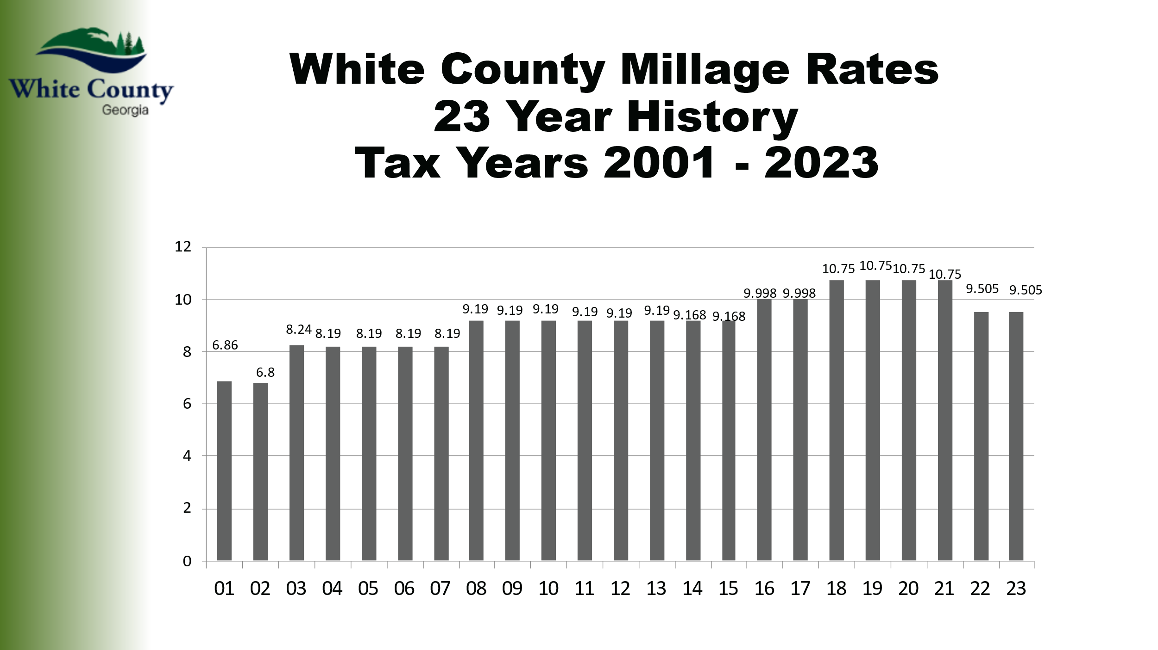
Mr. Larry Freeman stated that the 23-year history slide only shows the millage rate and does not show how much property values have increased. He did not understand why the millage rate needed to increase when values are increasing too – that the millage rate should remain the same because the digest increased.
With no additional public comments, Commissioner Bryant closed the floor.
Upon a motion made by Commissioner Goodger, seconded by Commissioner Holcomb there was a unanimous vote to adjourn the meeting.
The minutes of the July 20, 2023 Public Hearing were approved as stated this 7th day of August, 2023.
WHITE COUNTY BOARD OF COMMISSIONERS

s/Travis C. Turner
Travis C. Turner, Chairman

s/Terry D. Goodger
Terry D. Goodger, District 1

s/Lyn Holcomb
Lyn Holcomb, District 2

s/Edwin Nix
Edwin Nix, District 3

s/Craig Bryant
Craig Bryant, District 4

s/Shanda Murphy
Shanda Murphy, County Clerk

