WHITE COUNTY BOARD OF COMMISSIONERS
MINUTES OF THE COMBINED WORK SESSION & REGULAR MEETING HELD
MONDAY, JANUARY 8, 2024 AT 4:30 P.M.
The White County Board of Commissioners held a combined Work Session & Regular Meeting on Monday, January 8, 2024 at 4:30 p.m. in the Board Room at the Administration Building. Present for the meeting were: Chairman Travis Turner, Commissioner Terry Goodger, Commissioner Lyn Holcomb, Commissioner Edwin Nix, Commissioner Craig Bryant, County Manager Billy Pittard, County Attorney Mary Jane Henneke, Finance Director Jodi Ligon, and County Clerk Shanda Murphy.
Chairman Turner called the meeting to order.
Following the Pledge of Allegiance, Pastor Marc Turner - representing the Cleveland Worship Center & the White County Ministerial Alliance – provided the invocation.
Upon a motion made by Commissioner Bryant, seconded by Commissioner Goodger there was a unanimous vote to adopt the following meeting minutes: December 4, 2023 Public Hearing & Regular Meeting, December 11, 2023 Called Meeting, and December 14, 2023 Called Meeting including Executive Session.
Mr. Mark Griffin, former Director of White County Family Connection, introduced the new Director – Ms. Nanette Baughman. Mr. Griffin also provided the Board with an annual report pamphlet.
Chairman Turner read the following statement, as it appeared on the meeting agenda: “In reference to land use agenda item #6 – Georgia Zoning Procedures Law (O.C.G.A. 36-66-1, et seq.) requires a public hearing be advertised and held prior to any proposed zoning decision with a minimum of 10 minutes (per side) for both proponents and opponents to present data, evidence, and opinion. This requirement was met for the following item at the public hearing held at the Planning Commission Meeting on November 28, 2023. All information presented was then forwarded to the Board of Commissioners”.
Mr. John Sell, Director of Community & Economic Development, presented the land use application filed by Colin Morris to request a conditional use permit at 538 Highway 356 Helen, Georgia. Tax map and parcel 042B-045. Total acreage is 10.523. The proposed use was to place in a short-term rental program. The present zoning is R-1 Residential Single-Family. He stated that the property is not located in a subdivision, the Planning Commission held a public hearing on the application, and the Planning Commission recommended approval of the application. Mr. Colin Morris said he and his family had been visiting the area and enjoying the outdoors for years – so they decided to build a future retirement home. He explained that they wanted to operate the home as a short-term rental when they were not utilizing it. He confirmed that his wife would be self-managing the property.
Upon a motion made by Commissioner Bryant, seconded by Commissioner Nix there was a unanimous vote to approve the land use application filed by Colin Morris for a conditional use permit at 538 Highway 356 Helen, Georgia 30545. Tax map and parcel 042B-045. Total acreage is 10.523. The approved use is to place in a short-term rental program within the present zoning is R-1 Residential Single-Family.
Chief Deputy Gus Sesam presented the 2024 Inmate Housing Agreements with the Cities of Cleveland and Helen. He advised that the only change in these agreements from last year was the daily boarding fee increased from $35.00 per day to $45.00 per day in order to cover the increased costs of food and supplies.
Upon a motion made by Commissioner Goodger, seconded by Commissioner Holcomb, there was a unanimous vote to approve the 2024 Inmate Housing Agreements with the City of Cleveland and Helen.
Chairman Turner stated that the Board would be considering the adoption of Resolution No. 2024-01 amending Chapter 16, Short Term Rental Host License, of the County Code – noting that the following two (2) agenda items (amendments to Appendix C, Land Use Regulations) were all relate, however action would be taken on each item individually. Ms. Shanda Murphy presented the following information:
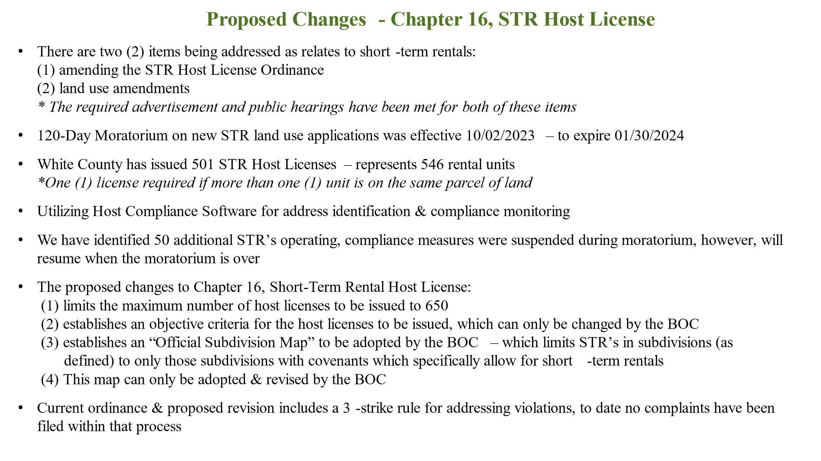
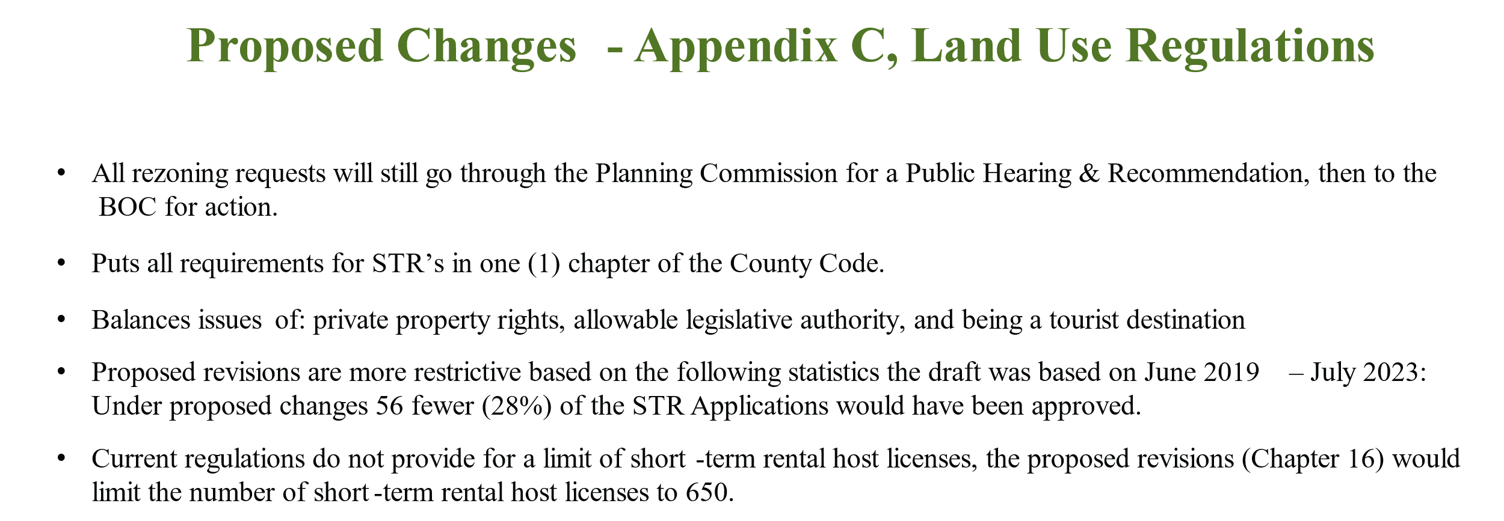There was discussion regarding the administration of the proposed host license limit and future revisions to the subdivision map.
Upon a motion made by Commissioner Goodger, seconded by Commissioner Holcomb there was a unanimous vote to adopt Resolution No. 2024-01 amending Chapter 16, Short-Term Rental Host License, of the County Code:
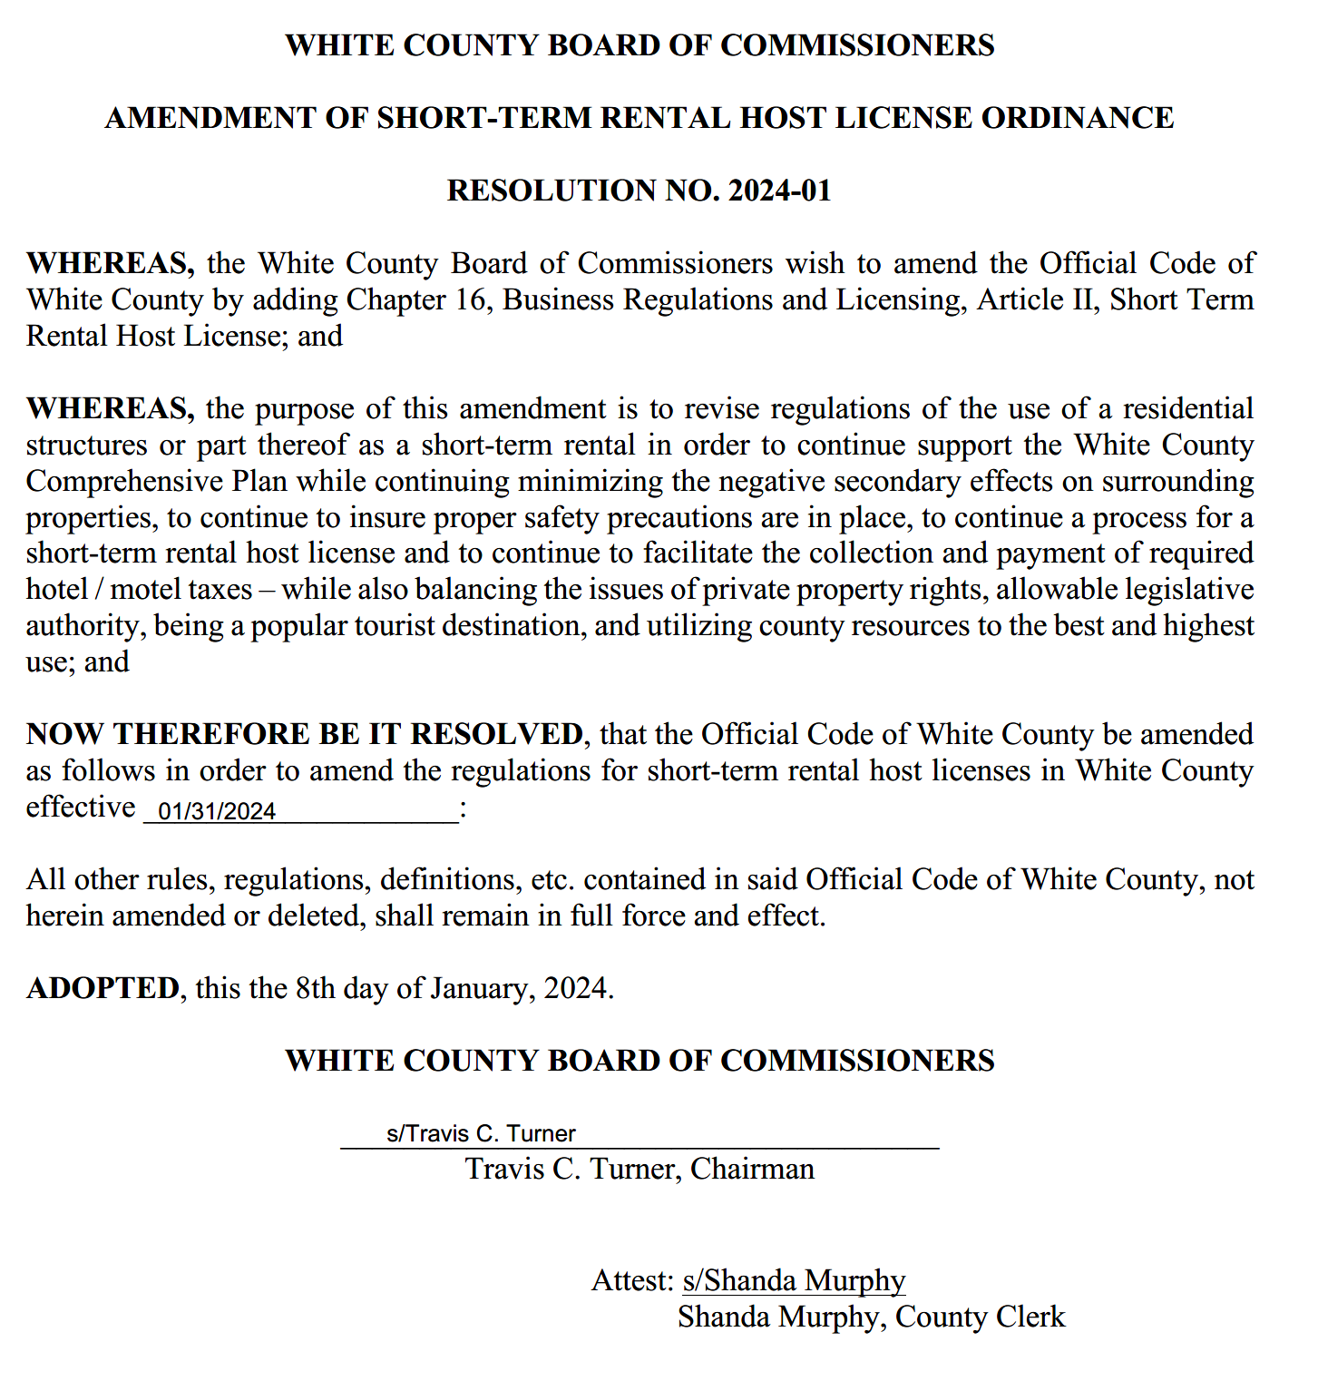
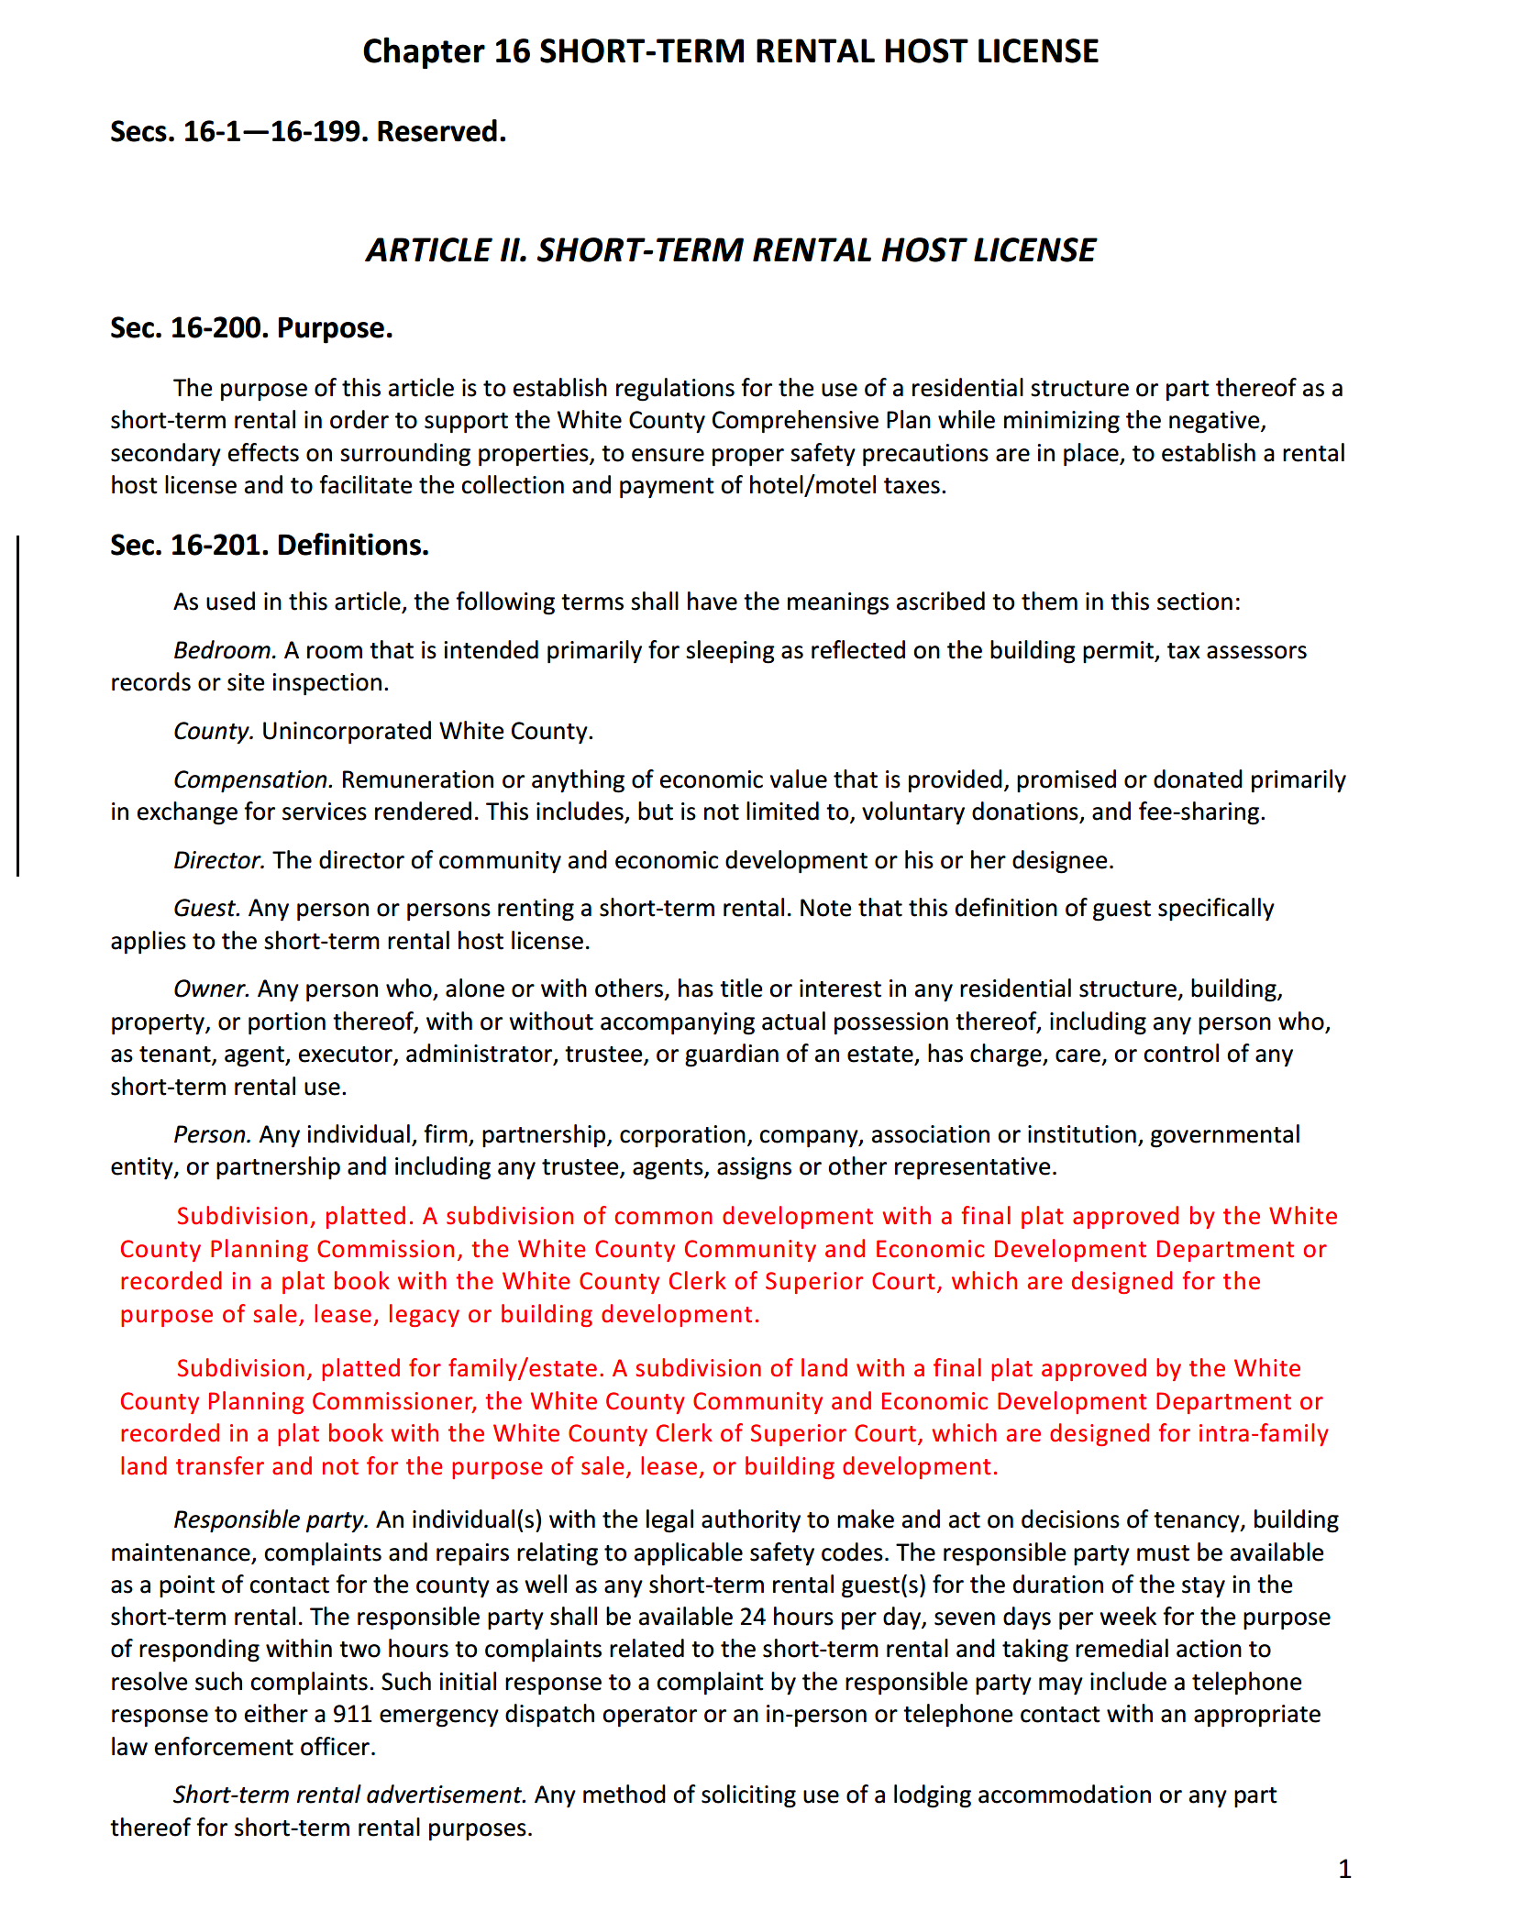
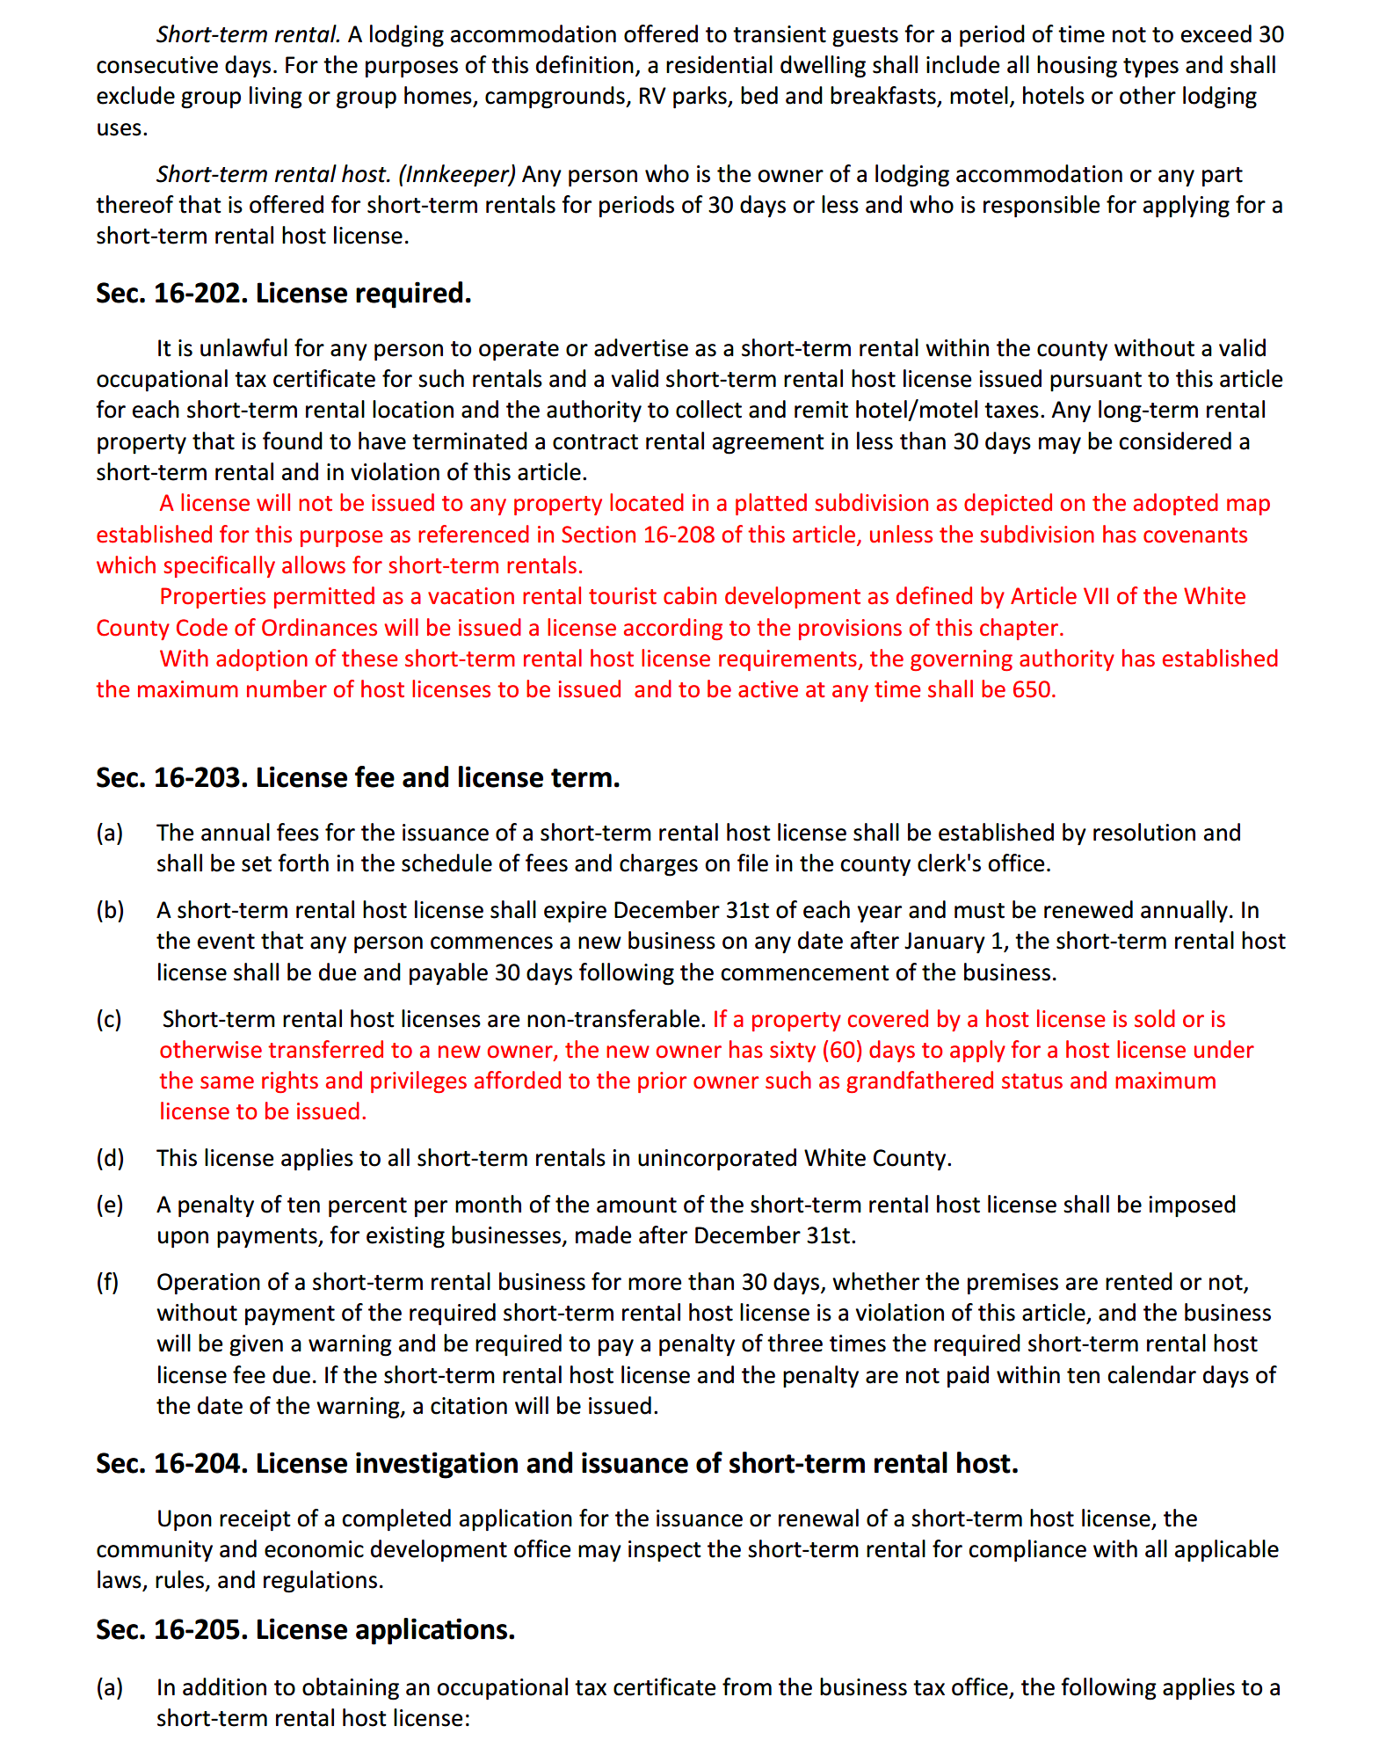
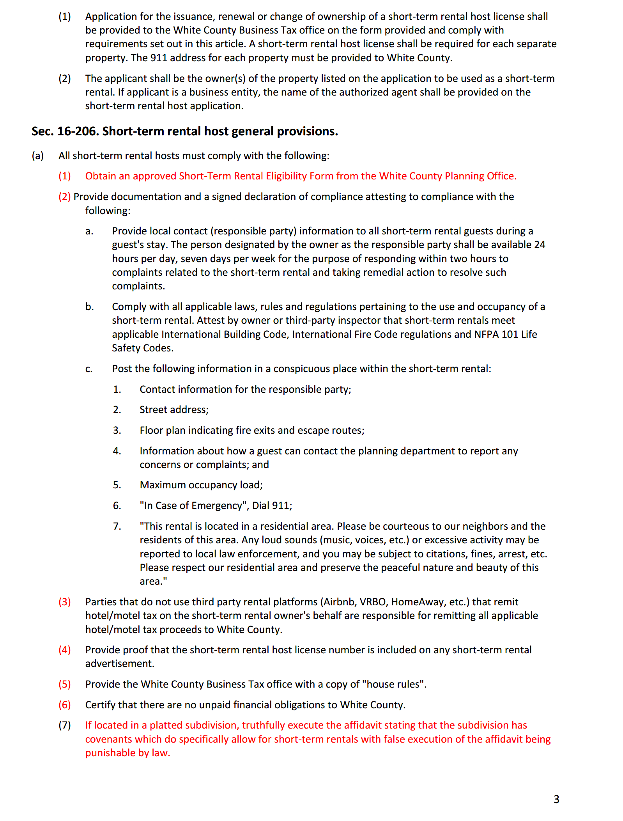
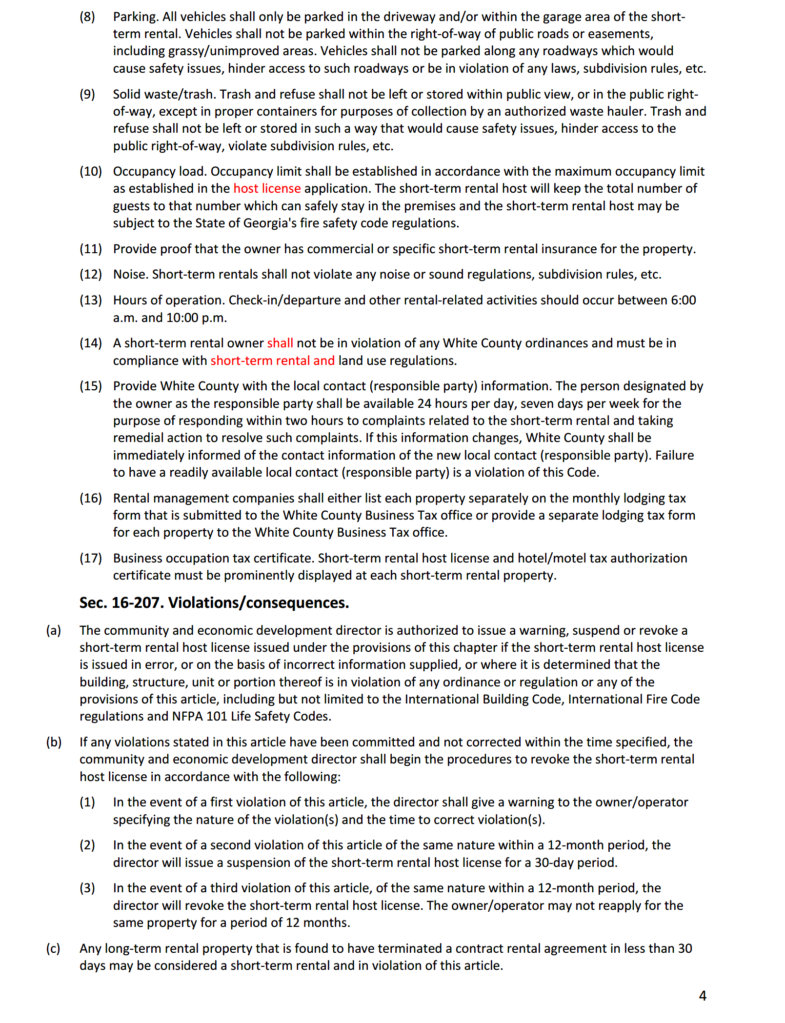
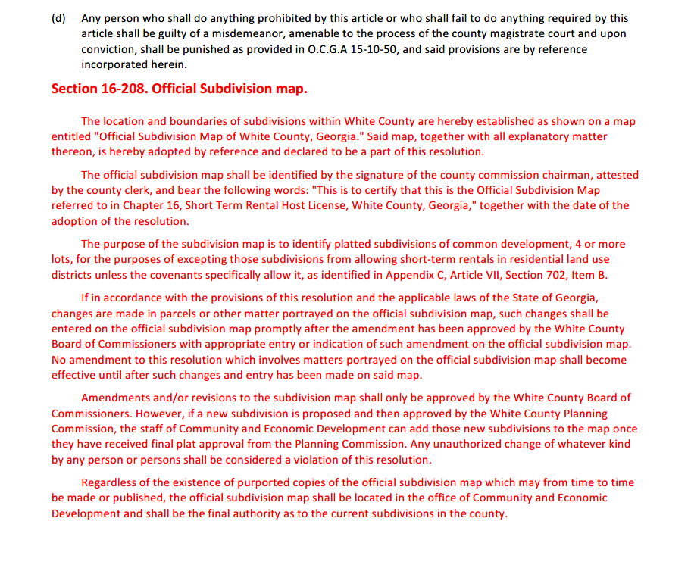
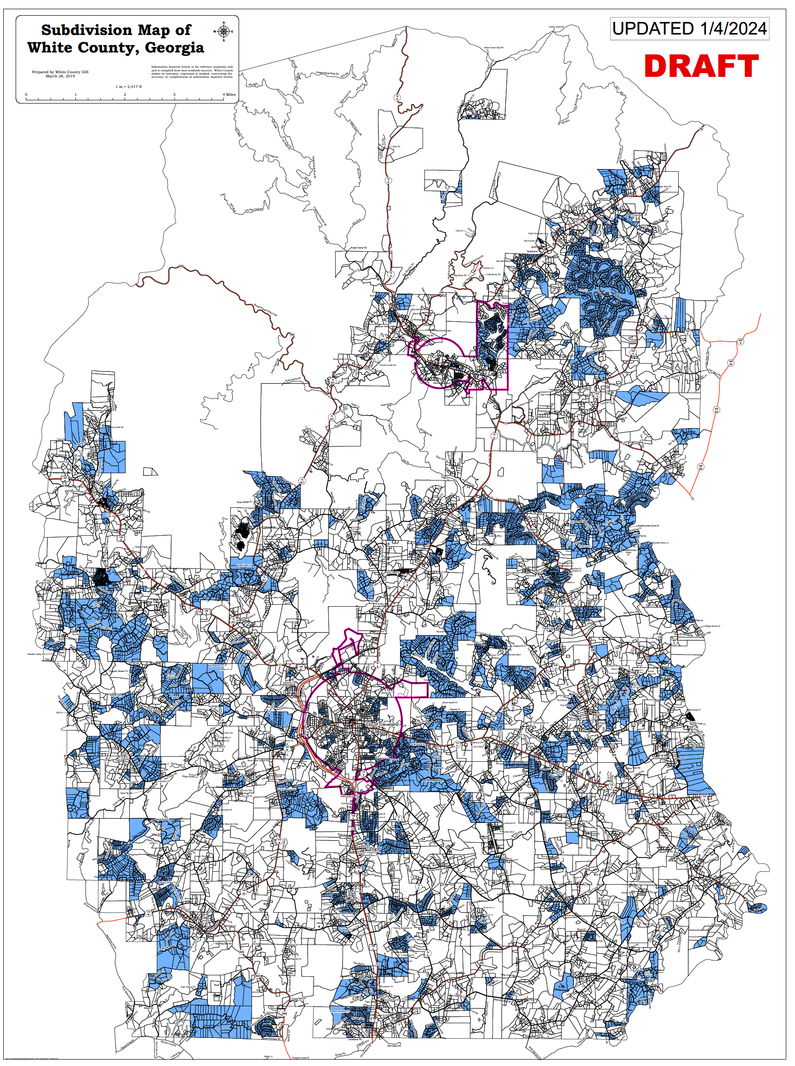
-End of County Resolution 2024-01-
Mr. Pittard summarized the amendments addressed by Resolution No. 2024-02, amending Appendix C, Land Use Regulations, of the County Code as relates to short-term rentals. He stated that with the passing of 2024-01, these amendments would allow short-term rentals as a permitted use in all residential zoning districts, except in subdivisions where there are no covenants that specifically allow for short-term rentals. He also stated that these amendments lay the groundwork for approval of short-term rentals as an administrative process (within the criteria adopted by the Board) instead of applications falling under the land use process and clarify that any approved conditional use runs with the property and not the owner.
Upon a motion made by Commissioner Holcomb, seconded by Commissioner Goodger, there was a vote to adopt Resolution No. 2024-02 amending Appendix C, Land Use Regulations, of the County Code – as relates to short-term rentals. Commissioner Nix and Chairman Turner voted in favor of the motion. Commissioner Bryant stated that he was not in favor of taking the approval of short-term rentals out of land use because he still wants to have public hearings on these since most are in his district and he would like to know where they are located. Commissioner Bryant opposed the motion. The motion to adopt County Resolution 2024-02 was approved by a 4-1 vote.
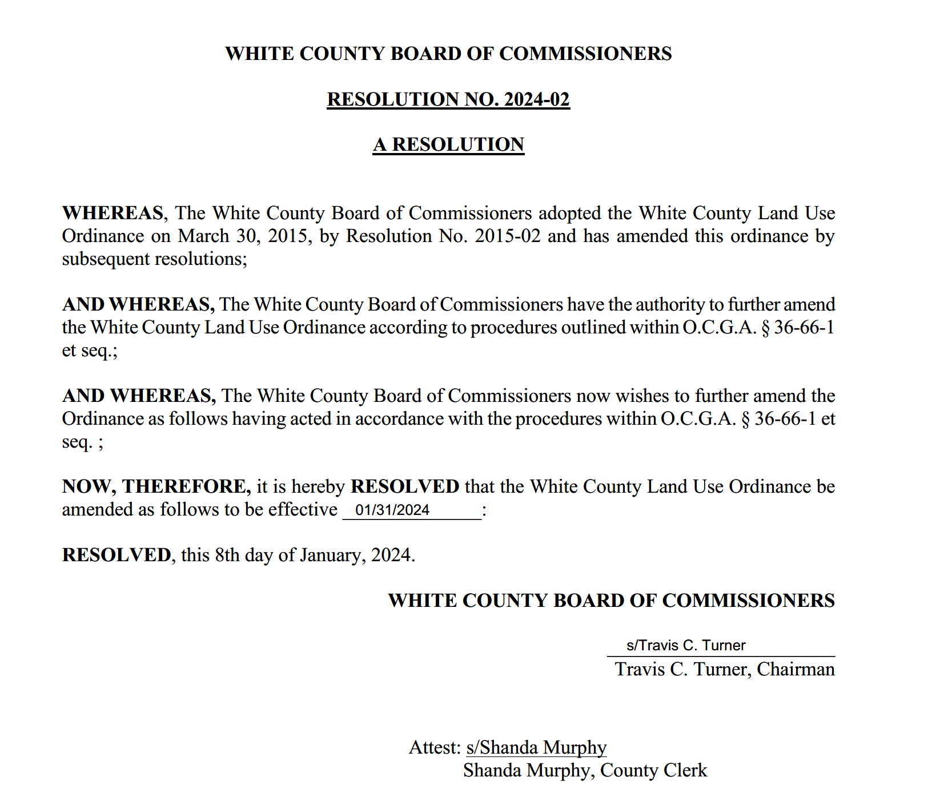
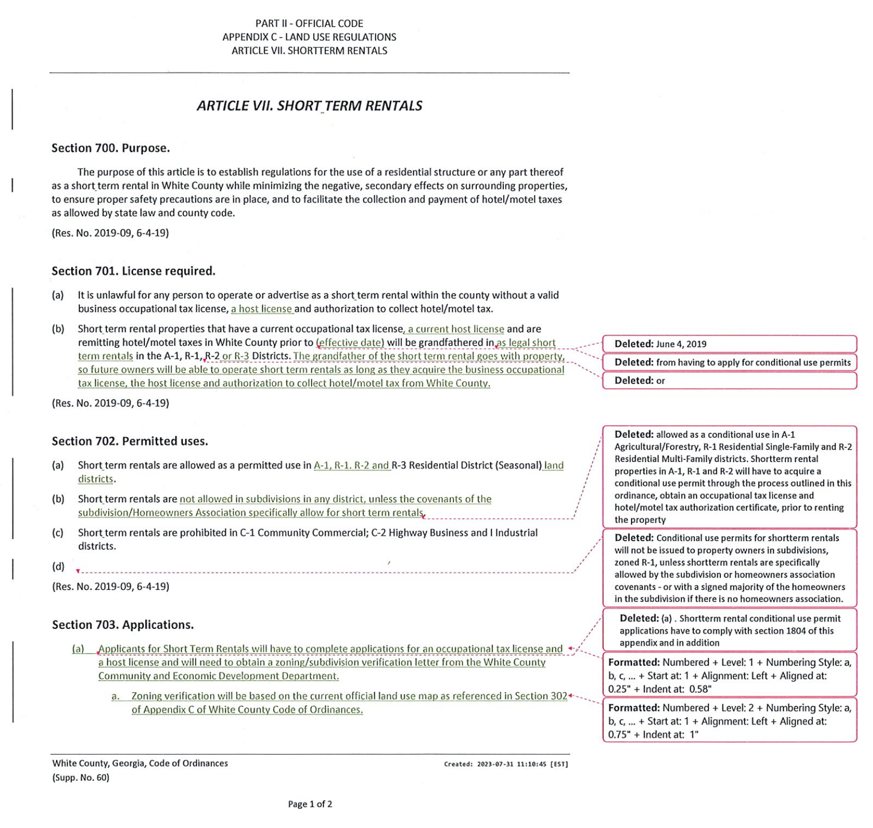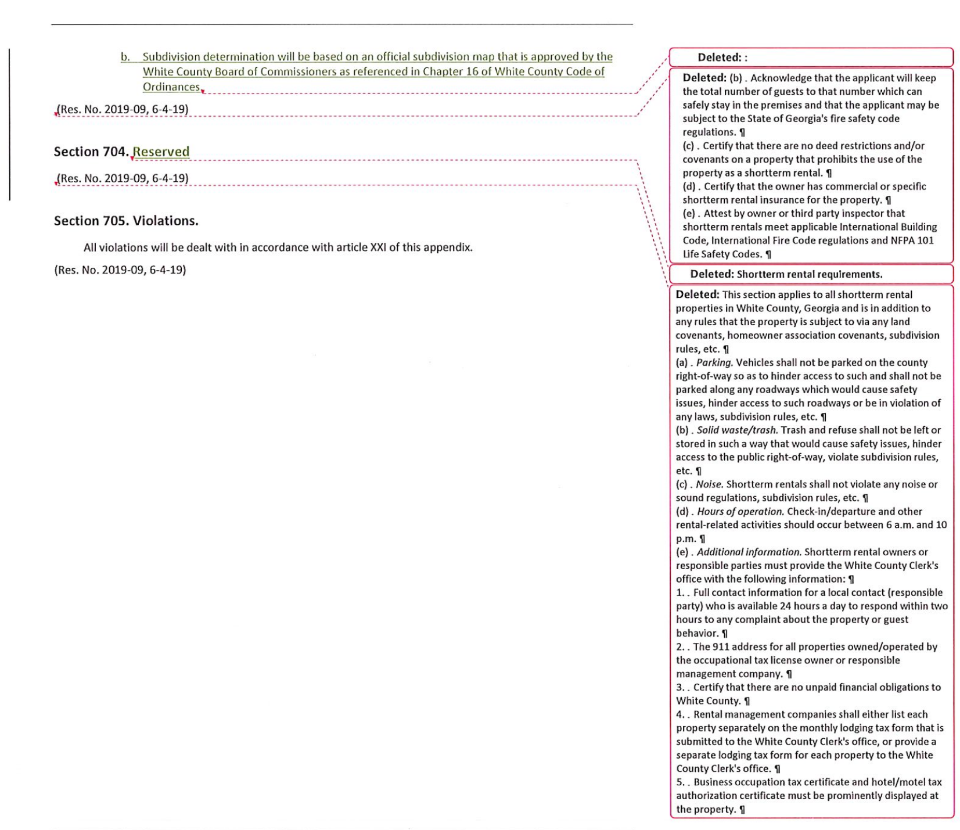
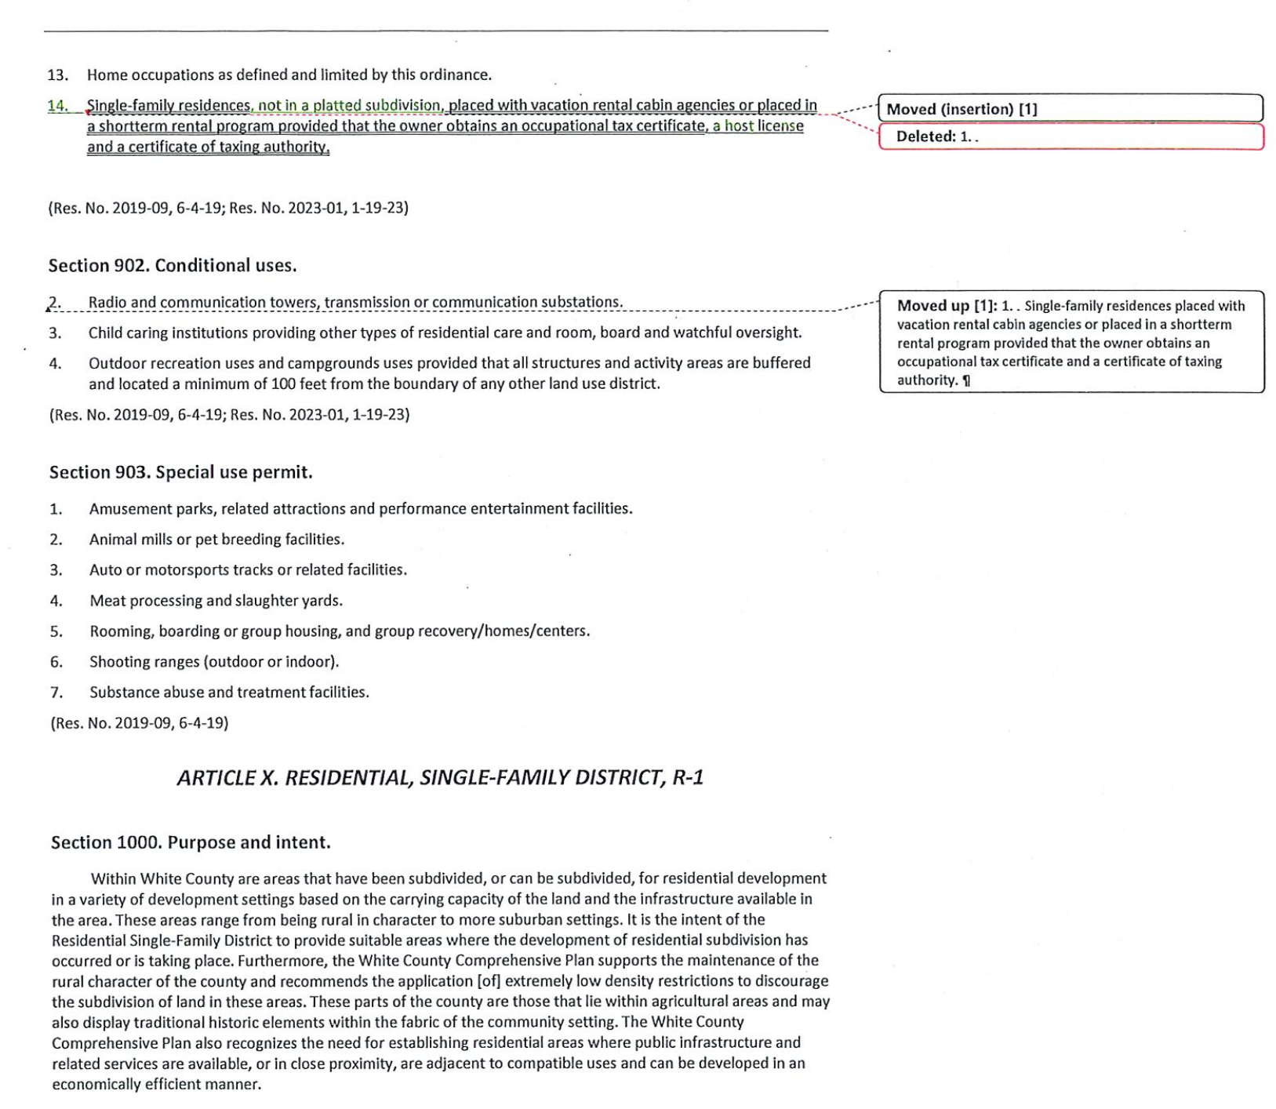
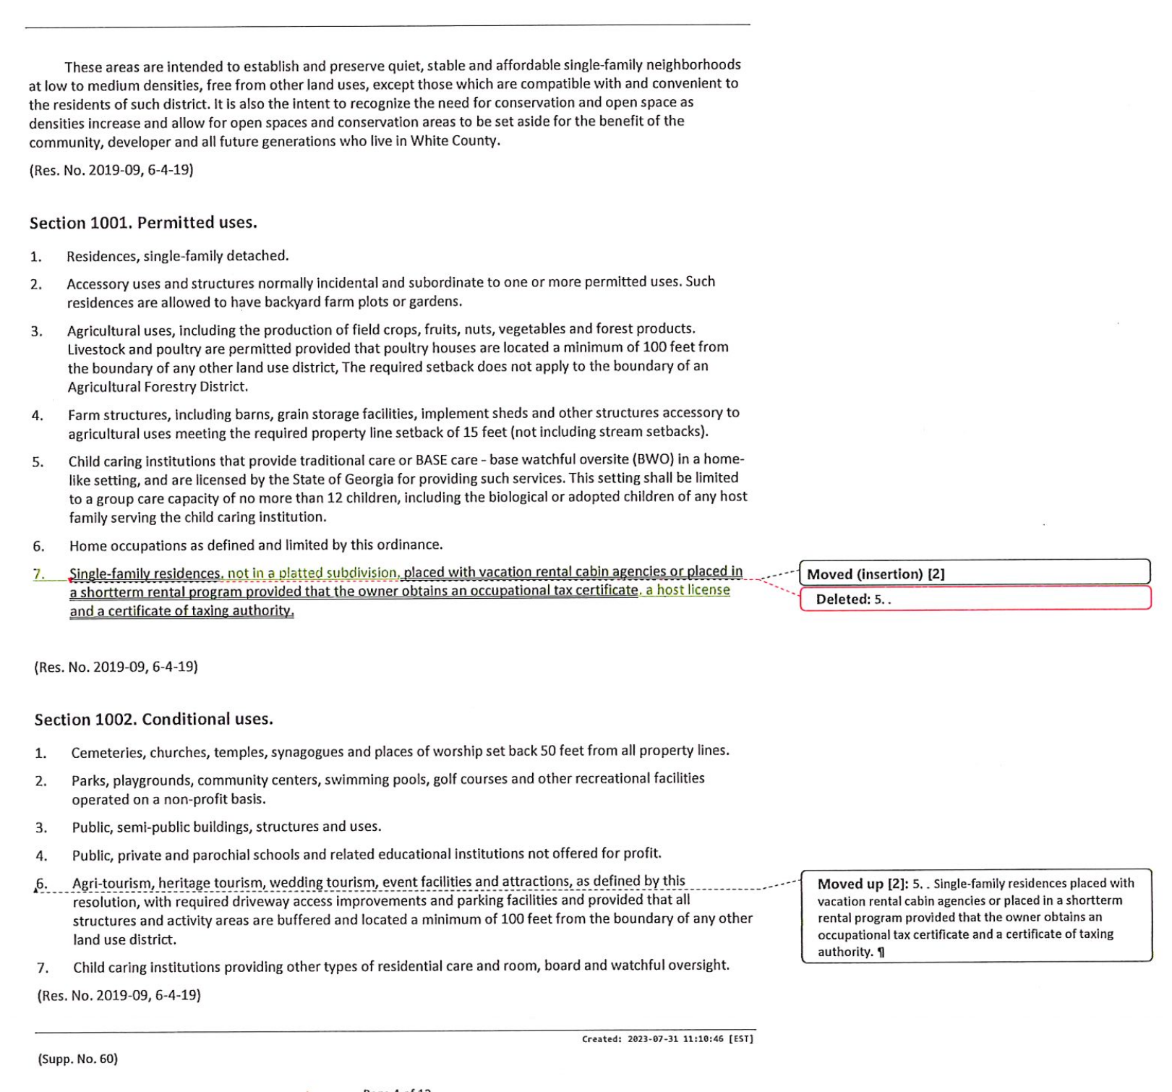
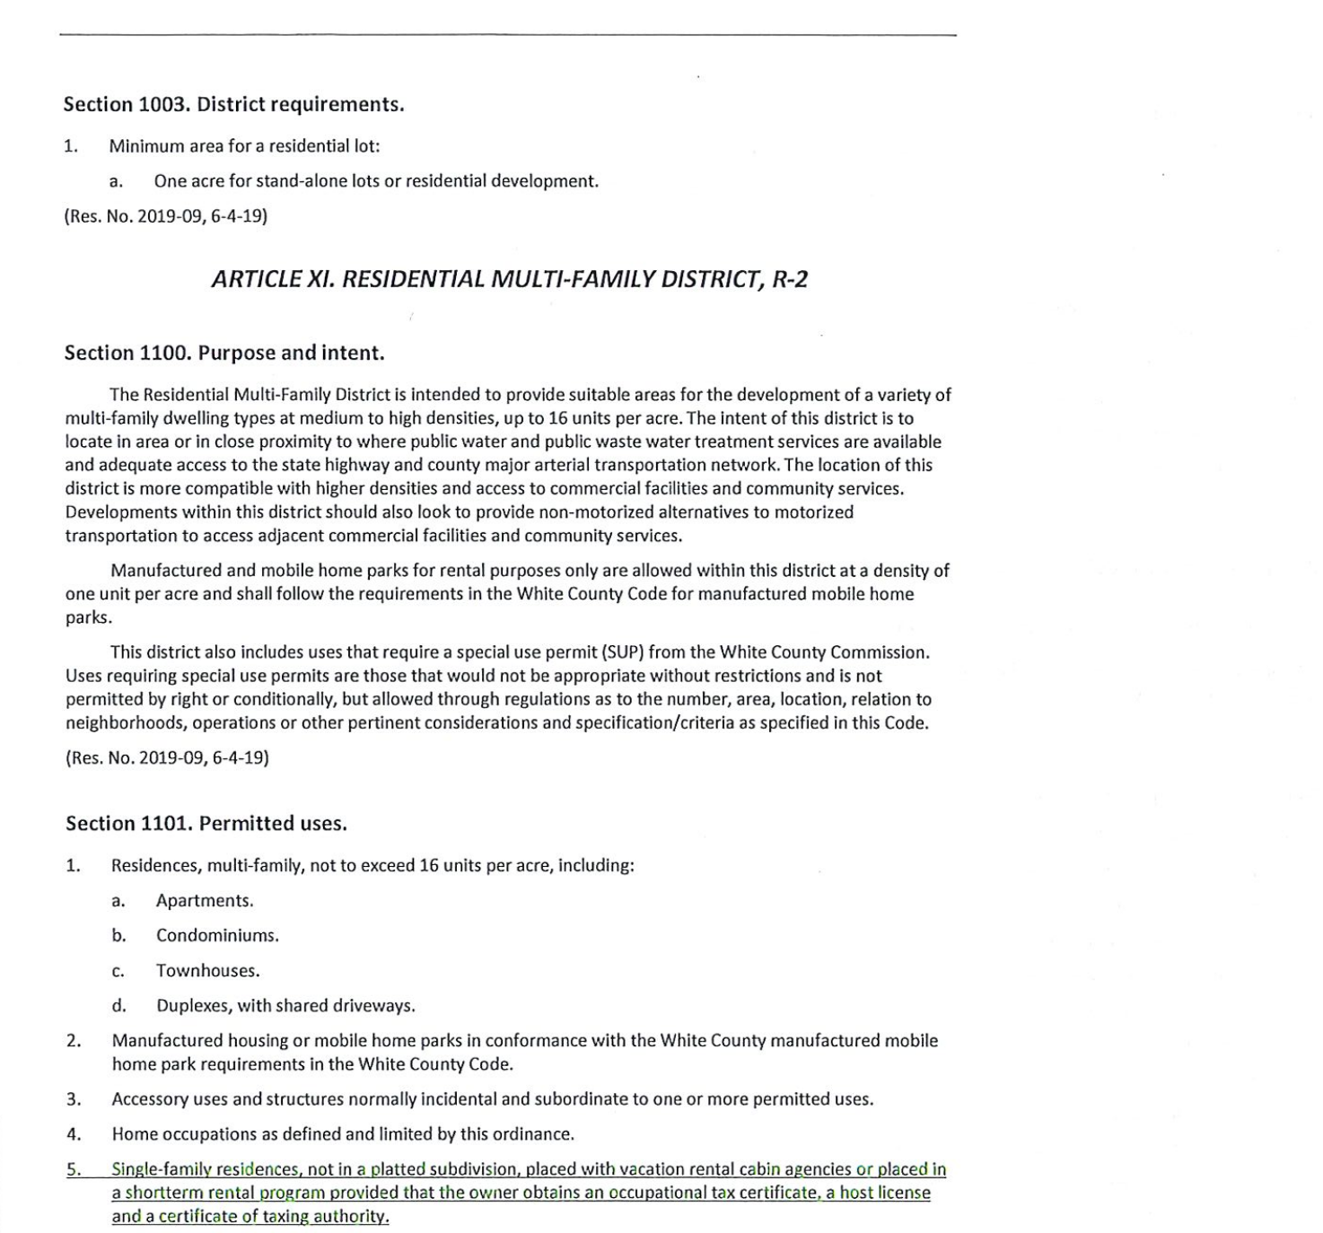
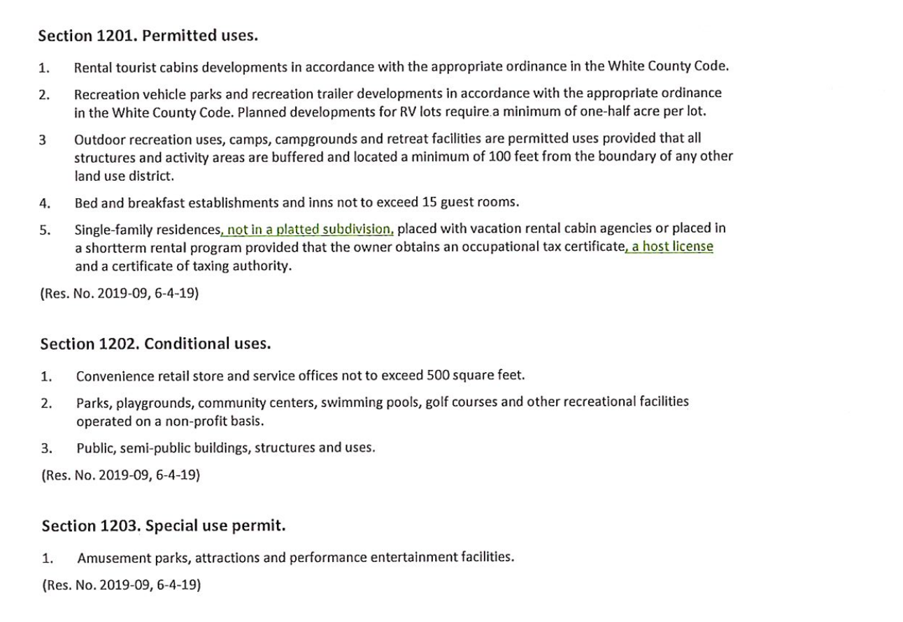
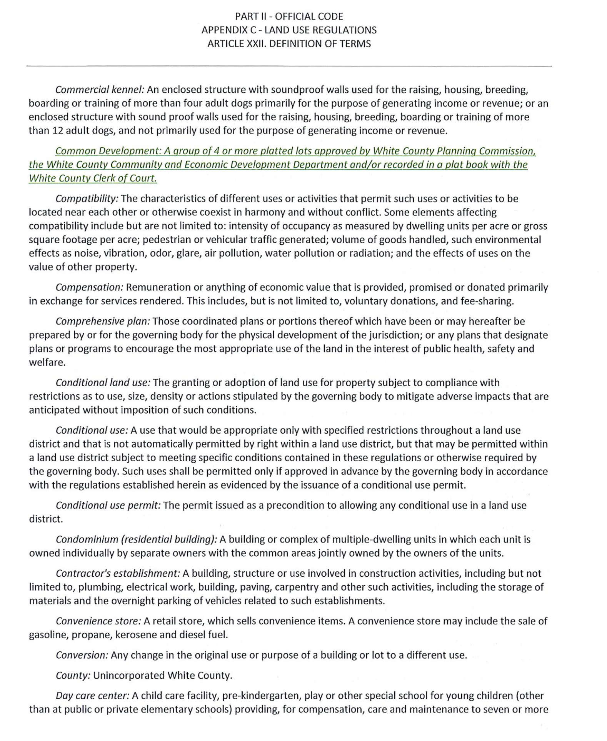
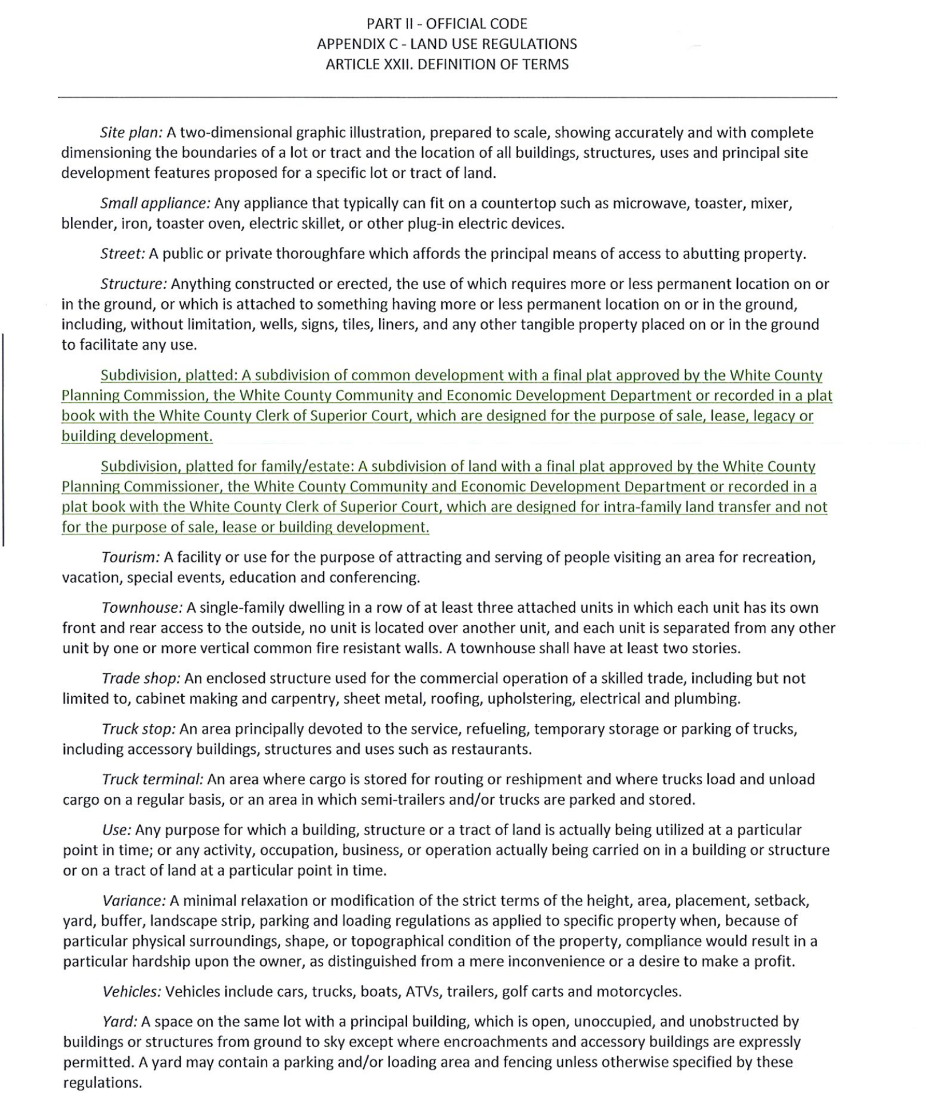
-End of County Resolution 2024-02-
Ms. Mary Jane Henneke, County Attorney, advised that Resolution No. 2024-03 amending Appendix C, Land Use Regulations Article XVIII, Amendment, Application and Procedural Requirements – with the addition of Section 1820, Judicial Review Procedures – as required by O.C.G.A 36-66-1 is related to changes the Georgia Legislature made to State Law during the 2021 Session and this resolution, although the county has been following the correct process, would bring the county code up to date on the required language as it relates to the appeals of land use decisions made by the Board of Commissioners. She stated that this requirement makes appeals to land use decisions uniform across the State.
Upon a motion made by Commissioner Nix, seconded by Commissioner Goodger there was a unanimous vote to adopt Resolution No. 2024-03 amending Appendix C, Land Use Regulations Article XVIII, Amendment, Application and Procedural Requirements – with the addition of Section 1820, Judicial Review Procedures – as required by O.C.G.A 36-66-1.
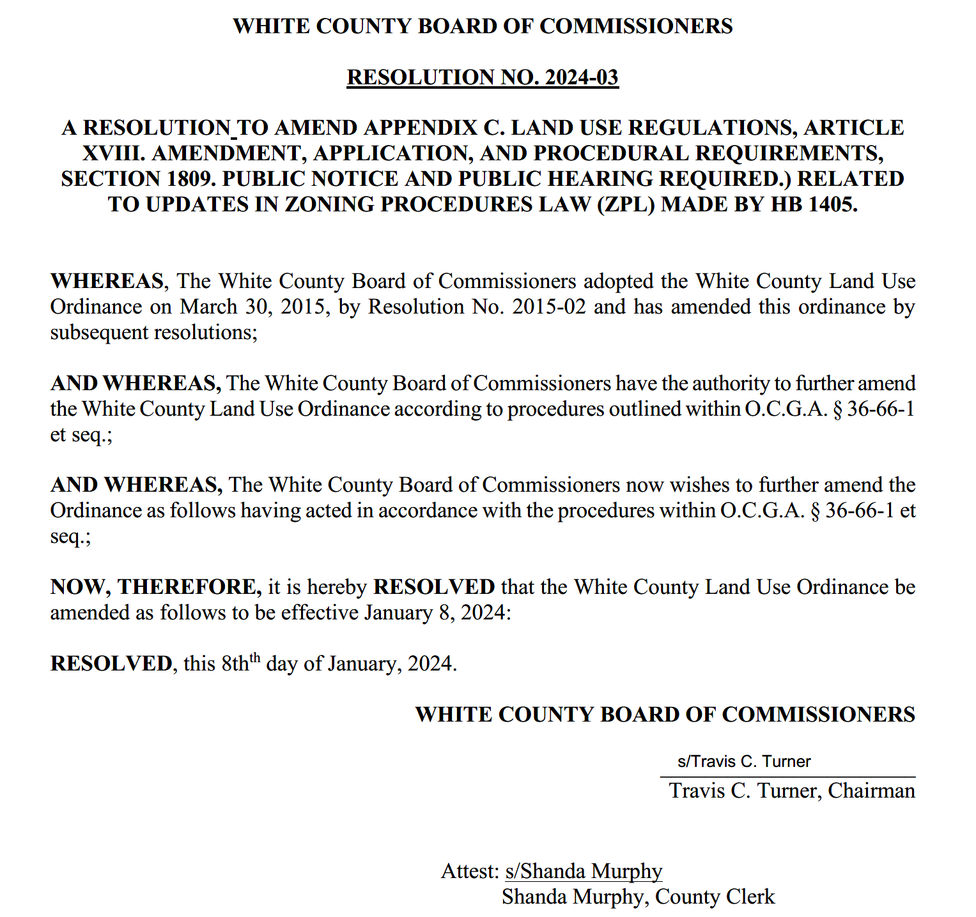

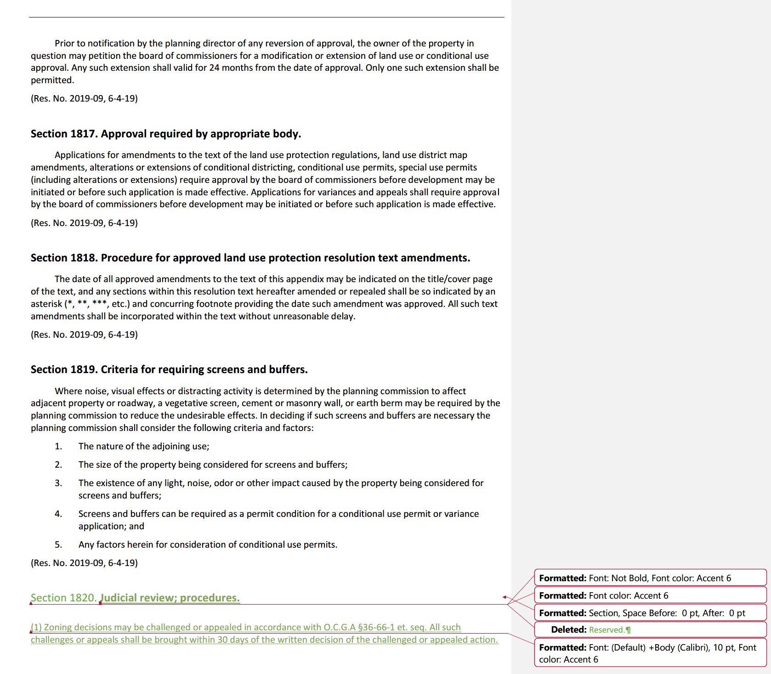
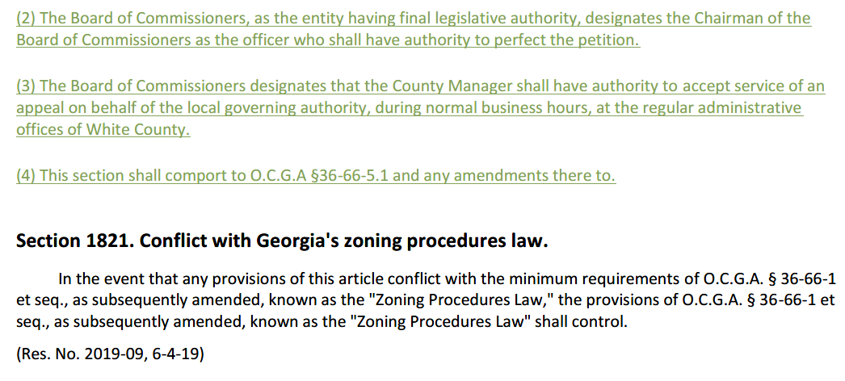
-End of County Resolution No. 2024-03-
Chairman Turner stated that the county had been working with the Cities of Cleveland and Helen to develop the 2024 SPLOST documents in order for the vote on this SPLOST continuation to be on the ballot in May 2024. He advised that the proposal was for the distribution to remain the same (60%/20%/20%) and each entity had developed the project lists for the use of these proceeds. Chairman Turner stated that uses for SPLOST funds included capital projects such as building, equipment, vehicles, infrastructure, etc. Mr. Pittard said the resolution before the Board would authorize the Chairman to execute the intergovernmental agreement with the cities based on the agreed upon parameters. Mr. Pittard noted that based on 3% growth, the estimated collections for this SPLOST is $56,700,000. This SPLOST, if passed by the voters of White County, would commence October 2026.
Upon a motion made by Commissioner Goodger, seconded by Commissioner Nix there was a unanimous vote to adopt County Resolution No. 2024-04 approving the 2024 SPLOST (Special Purpose Local Option Sales Tax) Intergovernmental Agreement (IGA) and authorizing the Chairman to execute the IGA on behalf of the County.
RESOLUTION NO. 2024-04
Resolution Approving a SPLOST Intergovernmental Agreement and
Authorizing the Chairman to Execute the Agreement on Behalf of the County
A RESOLUTION OF THE BOARD OF COMMISSIONERS OF WHITE COUNTY, GEORGIA APPROVING AND AUTHORIZING EXECUTION, BY THE CHAIRMAN OF THE WHITE COUNTY BOARD OF COMMISSIONERS, OF AN INTERGOVERMENTAL AGREEMENT BETWEEN THE COUNTY AND CERTAIN MUNICIPALITIES OF WHITE COUNTY CONCERNING A COUNTY ONE PERCENT SPECIAL PURPOSE LOCAL OPTION SALES AND USE TAX ENACTED PURSUANT TO O.C.G.A. § 48-8-110 ET SEQ.; REPEALING PRIOR RESOLUTIONS IN CONFLICT; AND FOR OTHER PURPOSES.
WHEREAS, O.C.G.A. § 48-8-110 et seq. authorizes the imposition of a one percent county special purpose local option sales and use tax (SPLOST) for the purposes inter alia of financing capital outlay projects to be owned or operated by the County and one or more municipalities; and
WHEREAS, White County, Georgia, the Municipality of Cleveland, Georgia, and the Municipality of Helen, Georgia desire to utilize the proceeds of a SPLOST for one or more of the purposes authorized under O.C.G.A. § 48-8-111 (a)(1).
NOW, THEREFORE, BE IT RESOLVED by the Board of Commissioners of White County, Georgia as follows:
SECTION 1.
The attached intergovernmental agreement addressing the disbursement of SPLOST proceeds among White County, the Municipality of Cleveland, and the Municipality of Helen and other related matters is hereby approved.
SECTION 2.
The Chairman of the White County Board of Commissioners is authorized to execute the intergovernmental agreement on behalf of the Board of Commissioners of White County, Georgia and affix the seal of the County thereto.
SECTION 3.
All resolutions, or parts of resolutions, in conflict herewith are repealed.
This the 8th day of January, 2024.
WHITE COUNTY, GEORGIA
By: s/Travis C. Turner ATTEST: s/Shanda Murphy
Travis Turner, Chairman Clerk
-End of County Resolution 2024-04-
Upon a motion made by Commissioner Holcomb, seconded by Commissioner Goodger there was a unanimous vote to adopt County Resolution No. 2024-05, setting the 2024 qualifying fee for each county office to be filled in the upcoming primary or election.
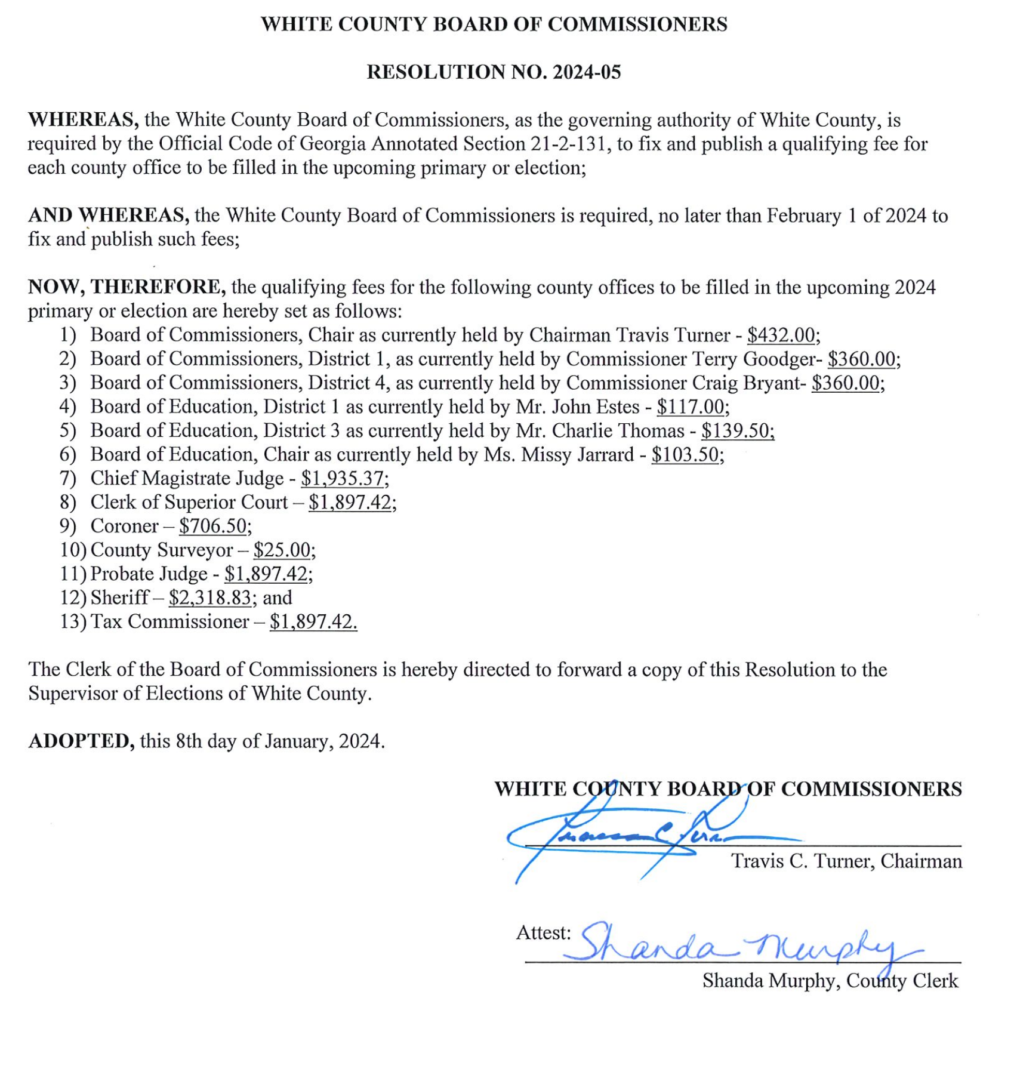
-End of County Resolution 2024-05-
Mr. Derick Canupp, Director of Public Works, presented a request for approval of the purchase of a replacement lowboy tractor through Sourcewell Cooperative Purchasing Program. He stated that the current tractor being used is a 1986 model and it cannot pass a pre-trip inspection. He provided photos of the current tractor. He said this would either be a 2023 or a 2024 model and would not be delivered until the 4th quarter of 2024. The price through Sourcewell would be $142,632.00 and they would also need to purchase a trailer to be utilized with this tractor once the tractor is received.
Upon a motion made by Commissioner Nix, seconded by Commissioner Bryant there was a unanimous vote to approve purchase of a replacement lowboy tractor (Mack Pinnacle 64T DayCab) for Public Works through the Sourcewell Cooperative Purchasing Program in the amount of $142,632.00 – to be funded by SPLOST.
Upon a motion made by Commissioner Goodger, seconded by Commissioner Holcomb there was a unanimous vote to accept the 2024 Edward Byrne Memorial Justice Assistance Grant ($500,000.00) for the Appalachian Regional Drug Enforcement Office (ARDEO) for which White County serves as the fiscal agent.
Ms. Jodi Ligon presented the monthly financial status report (see attached).
During County Manager Comments, Mr. Pittard stated that the transition to White County managing the Transfer Station was going very well. He said that Mr. Canupp had done an excellent job facilitating the transition along with the assistance of several other county departments.
Chairman Turner asked each Commissioner if they had any comments – there were none.
Chairman Turner opened the floor for public comment.
Ms. Teresa Stansel, 2521 Adair Mill Road Cleveland, Ga – read and submitted a prepared statement (with exhibits) for the meeting record which was placed in the meeting file. In summary, comments made were concerning an ethics complaint filed with complaints against Commissioner Bryant for improper filing of his personal financial disclosure & conflict of interest and against Karen Thomas for unregistered lobbying.
Ms. Mitchelle Johnson, 431 Gold Flume Way Cleveland, Ga – asked for clarification on the proceedings taking place to address the non-compliant short-term rentals which had been identified. Ms. Murphy explained that once a non-compliant short-term rental is identified – a first notice is sent to the property owner, if there is no response a second notice is sent, and if there is still no response the matter is turned over to Code Enforcement who will take the necessary steps to file code violations in Magistrate Court against the owner.
Lillian Hall, 543 Leigh’s Crossing Cleveland, Ga – read and submitted a prepared statement for the meeting record which was placed in the meeting file. In summary, comments made were concerning the issues of the ethics complaint filed by Ms. Stansel, the negative effects of the actions taken related to short-term rentals, and overall displeasure with the Board.
Chris Dorsey, 164 Mill Lane Cleveland, Ga - read and submitted a prepared statement for the meeting record which was placed in the meeting file. In summary, comments were related to short-term rentals as approved not meeting ADA (American with Disabilities Act) standards.
Trish Betterton, 1810 Kellum Valley Road Cleveland, Ga - read and submitted a prepared statement for the meeting record which was placed in the meeting file. In summary, comments made were concerning the issues of the ethics complaint filed by Ms. Stansel, the negative effects of the actions taken related to short-term rentals, and overall displeasure with the Board.
Shane Betterton, 347 Antioch Church Road Cleveland, Ga - read and submitted a prepared statement for the meeting record which was placed in the meeting file. In summary, comments made were concerning the issues of the negative effects of the actions taken related to short-term rentals, and overall displeasure with the Board and County Manager.
Axel Jones, 2327 Asbestos Road Cleveland, Ga – asked about the liability of the County in response to Mr. Dorsey’s comments regarding short-term rentals not meeting federal ADAA (Americans with Disabilities Act). Chairman Turner stated that this would be discussed with the County Attorney.
Following announcements and upon a motion made by Commissioner Nix, seconded by Commissioner Goodger, there was a unanimous vote to adjourn the meeting.
The minutes of the January 8, 2024 Work Session & Regular Meeting were approved as stated this 5th day of February, 2024.
WHITE COUNTY BOARD OF COMMISSIONERS
s/Travis C. Turner
Travis C. Turner, Chairman
s/Terry D. Goodger
Terry D. Goodger, District 1
s/Lyn Holcomb
Lyn Holcomb, District 2

s/Edwin Nix
Edwin Nix, District 3

s/Craig Bryant
Craig Bryant, District 4

_________________________________________
Shanda Murphy, County Clerk

