WHITE COUNTY BOARD OF COMMISSIONERS
MINUTES OF THE WORK SESSION & CALLED MEETING HELD
MONDAY, JANUARY 29, 2024 AT 4:30 P.M.
The White County Board of Commissioners held a Work Session & Called Meeting on Monday, January 29, 2024 at 4:30 p.m. in the Board Room at the Administration Building. Present for the meeting were: Chairman Travis Turner, Commissioner Terry Goodger, Commissioner Lyn Holcomb, Commissioner Edwin Nix, Commissioner Craig Bryant, County Manager Billy Pittard, Finance Director Jodi Ligon, and County Clerk Shanda Murphy.
Chairman Turner called the meeting to order.
He asked for a motion to amend the meeting agenda by adding consideration to adopt County Resolution 2024-6, Calling for an Election to Impose a County Special Purpose Local Option Sales Tax (SPLOST) to the agenda as the final business item.
Upon a motion made by Commissioner Holcomb, seconded by Commissioner Goodger there was a unanimous vote to amend the agenda by adding consideration to adopt County Resolution 2024-06, Calling for an Election to Impose a County Special Purpose Local Option Sales Tax (SPLOST) to the end of the business items agenda.
Chairman Turner read the following statement from the meeting agenda – “In reference to land use agenda item #2 & #3 – Georgia Zoning Procedures Law (O.C.G.A. 36-66-1, et seq.) requires a public hearing be advertised and held prior to any proposed zoning decision with a minimum of 10 minutes (per side) for both proponents and opponents to present data, evidence, and opinion. This requirement was met for the following item at the public hearing held at the Planning Commission Meeting on December 27, 2023. All information presented was then forwarded to the Board of Commissioners”.
Mr. John Sell, Director of Community & Economic Development, presented the land use application filed by Tamara and Lawrence Adelberg to redistrict property located at 37 Thornblade Trail Cleveland, Georgia from C-1, Community Commercial District to R-1, Residential Single-Family District. Tax map and parcel 017-094C. Total acreage is 1.16. He stated the Planning Commission had held a public hearing on the application, there was no opposition to the application, and the Planning Commission recommended approval of the application. He also advised that the property is the Adelberg’s residence, they are in the process of selling the property, and during this process they realized the property was zoned commercial – which has caused issue with selling the residential property. Mr. Sell stated that the property fronting Hwy 129 N and its proximity to other commercial properties probably contributed to this property being zoned for commercial when land use regulations were first adopted. Mr. Adelberg confirmed the information stated by Mr. Sell.
Upon a motion made by Commissioner Nix, seconded by Commissioner Goodger there was a unanimous vote to approve the land use application filed by Tamara and Lawrence Adelberg to redistrict property located at 37 Thornblade Trail Cleveland, Georgia from to C-1, Community Commercial District to R-1, Residential Single-Family District. Tax map and parcel 017-094C. Total acreage is 1.16.
Mr. Sell presented the land use application filed by David Fain to request a conditional use permit at 220 Black Road Cleveland, Georgia. Tax map and parcel 062-032. Total acreage is 23.32. The proposed use is a telecommunications tower. The present zoning is A-1, Agriculture Forestry District. He stated the Planning Commission held a public hearing on the application, there was opposition expressed to the application due to surrounding neighbors being concerned about obstructing the view shed and safety concerns regarding the radio waves that would be omitted by the tower. Mr. Sell also stated that there was one person who spoke in support of the application due to the need for increased cellular coverage in the area. He advised that Mr. Fain owns the surrounding 50 acres with the entire fall zone for the tower being on his property and initially the tower would provide coverage for AT&T with other carriers to follow. Mr. Fain stated that his personal residence is the closest residence to the tower so he would be impacted greater than anyone else and he had been in the cell tower industry for 30+ years and he could say there are no known negative effects from the radio waves.
Upon a motion made by Commissioner Holcomb, seconded by Commissioner Goodger there was a unanimous vote to approve the land use application filed by David Fain for a conditional use permit at 220 Black Road Cleveland, Georgia. Tax map and parcel 062-032. Total acreage is 23.32. The approved use is a telecommunications tower within the present zoning of A-1, Agriculture Forestry District.
Mr. David Murphy, Director of Public Safety, presented proposed revisions to Sections 26-126 and 26-128 of the White County Code relating to volunteer fire compensation and participation requirements to reflect current operational changes and to promote retention and recruitment. He advised that the nationwide decrease in volunteer firefighters had been discussed several times and within the current budget the department was authorized to increase the per call pay for volunteer firefighters from $15.00 to $30.00 on a trial basis. He stated that this measure had helped to retain the existing, active volunteers. He requested that the change to $30.00 per call be codified in Section 26-126 and stated the current budget would be sufficient to cover this. He also stated that the revisions noted to Section 26-128 were needed in order to accurately reflect the attendance and state mandated standards. He advised that currently Fire Services has 18 active volunteer firefighters and three recruits in process. The Board asked if volunteers received the per call pay for training and Mr. Murphy stated they did not. The Board expressed an interest in looking at possibly including pay for training in some way in the future.
Upon a motion made by Commissioner Bryant, seconded by Commissioner Goodger there was a unanimous vote to approve County Resolution 2024-07 revising Sections 26-126 and 26-128 of the White County Code relating to volunteer fire compensation and participation requirements to reflect current operational changes and to promote retention and recruitment as follows:
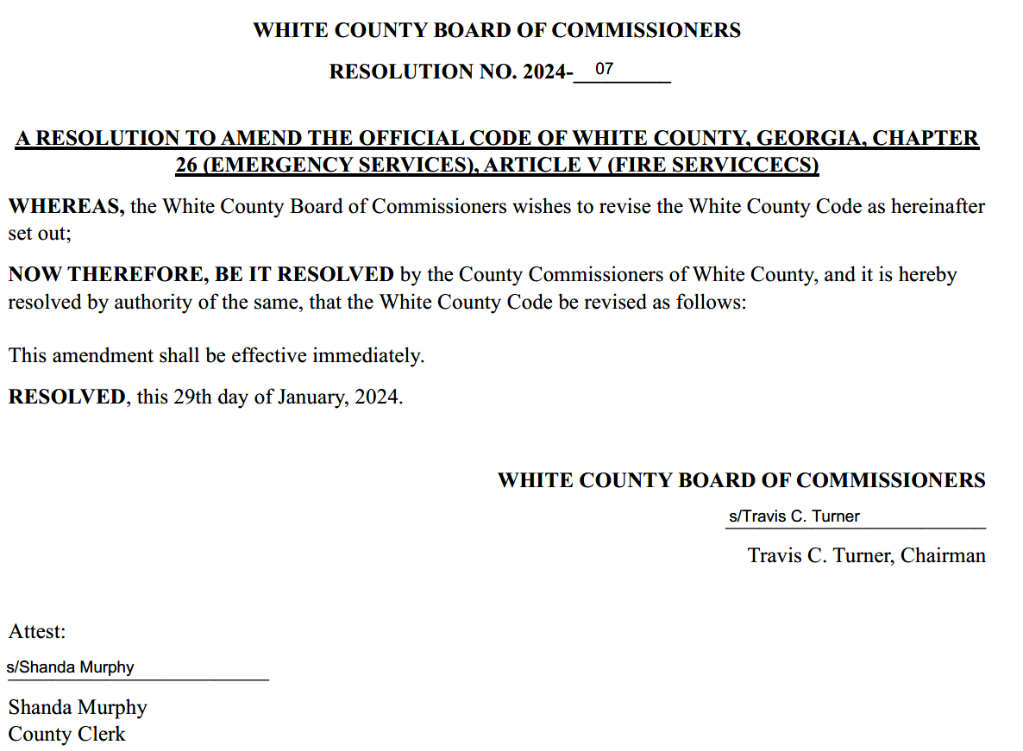
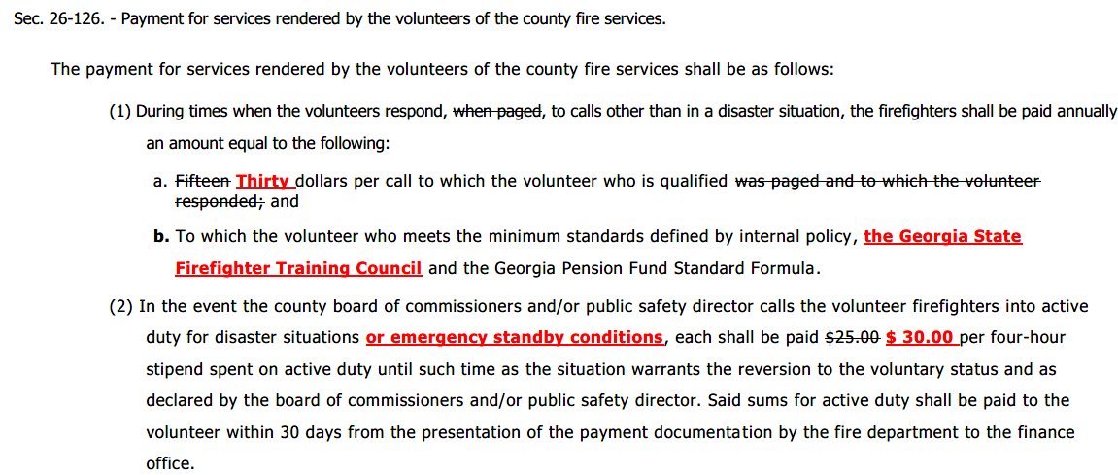
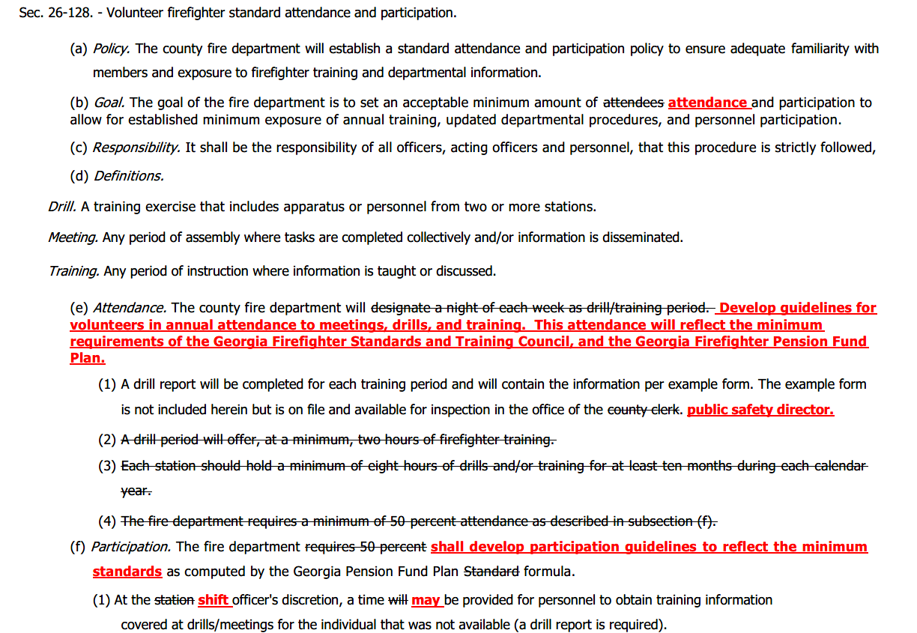
-End of County Resolution 2024-07-

Mr. Murphy presented the new agreement for statewide mutual aid during emergency and disaster response. He stated that this agreement must be approved every 3 to 4 years with the last agreement being approved in 2020. He did note that the agreement language was the same as the previous agreement. He stated this was a very beneficial agreement to be under when needed and White County had been both the recipient and provider of assistance under this agreement.
Upon a motion made by Commissioner Nix, seconded by Commissioner Holcomb there was a unanimous vote to approve the new (2024) agreement for statewide mutual aid during emergency and disaster response.
Mr. Derick Canupp, Director of Public Works, presented a quote for repairs to Westmoreland Road for damage which was caused by a car fire in June 2023. He stated that the repairs were bid out and the low bidder, once contacted, could no longer perform the work and the estimate sent to the third party’s insurance was based on the quote from the low bidder. Therefore, he had been working to obtain another quote closer to the original cost, which the insurance had already paid to the county in the amount of $29,700.00. Mr. Canupp stated that he had obtained a quote from Colditz Trucking in the amount of $30,000.00 which would utilize a sufficient repair method, although different from the initial quote received. The Board expressed their displeasure with the initial low bid falling through.
Upon a motion made by Commissioner Nix, seconded by Commissioner Holcomb, there was a unanimous vote to approve repairs to Westmoreland Road in the amount $ 30,000.00 from Colditz Trucking – to be paid by insurance claim proceeds.
Ms. Jodi Ligon presented information regarding a grant received by the Enotah Judicial Circuit through the American Rescue Plan Act (ARPA). She reviewed that the Board and Circuit approved the grant application in the Fall with the total grant award being $1,653,313.00 with $1,300,000.00 being for audio visual equipment improvements in White, Lumpkin, and Union counties.
Upon a motion made by Commissioner Nix, seconded by Commissioner Goodger there was a unanimous vote to accept the grant awarded to the Enotah Judicial Circuit through the American Rescue Plan Act (ARPA) in the amount of $1.653,313.00 with White County serving as the fiscal agent.
Upon a motion made by Commissioner Holcomb, seconded by Commissioner Goodger there was a unanimous vote to appoint Commissioner Craig Bryant as the Vice-Chair for the 2024 calendar year.
Mr. Billy Pittard presented County Resolution 2024-6, Calling for an Election to Impose a County Special Purpose Local Option Sales Tax (SPLOST). He stated that the Board of Commissioners, Cleveland City Council, and the Helen City Commission had recently approved the Intergovernmental Agreement (IGA) related to the continuation of the Special Purpose Local Option Sales Tax (SPLOST) which is planned to be placed on the May 2024 voting ballot and the next step in this process is the Board issuing a call for this referendum so the Elections Supervisor can have the ballot language created through the Secretary of State’s Office.
Upon a motion made by Commissioner Goodger, seconded by Commissioner Holcomb there was a unanimous vote to adopt County Resolution 2024-06 as follows:

RESOLUTION NO. 2024-06
Resolution Calling for an Election to Impose
a County Special Purpose Local Option Sales Tax
A RESOLUTION OF THE BOARD OF COMMISSIONERS OF WHITE COUNTY, GEORGIA IMPOSING A COUNTY ONE PERCENT SALES AND USE TAX AS AUTHORIZED BY PART 1 OF ARTICLE 3 OF CHAPTER 8 OF TITLE 48 OF THE OFFICIAL CODE OF GEORGIA ANNOTATED, SPECIFYING THE PURPOSES FOR WHICH THE PROCEEDS OF SUCH TAX ARE TO BE USED; SPECIFYING THE PERIOD OF TIME FOR WHICH SUCH TAX SHALL BE IMPOSED; SPECIFYING THE ESTIMATED COST OF THE FACILITIES TO BE FUNDED FROM THE PROCEEDS OF SUCH TAX; REQUESTING THE ELECTION SUPERINTENDENT TO CALL AN ELECTION OF THE VOTERS OF WHITE COUNTY TO APPROVE THE IMPOSITION OF SUCH SALES AND USE TAX; APPROVING THE FORM OF BALLOT TO BE USED IN SUCH AN ELECTION; AND FOR OTHER PURPOSES.
WHEREAS, Part 1 of Article 3 of Chapter 8 of Title 48 of the Official Code of Georgia Annotated. (the “Act”) authorizes the imposition of a county one percent sales and use tax (the “SPLOST”) for the purpose, inter alia, of financing certain capital outlay projects which include those set forth herein; and
WHEREAS, the Board of Commissioners of White County, Georgia (the “Board of Commissioners”) has determined that it is in the best interest of the citizens of White County, Georgia (the “County”) that a one percent SPLOST be imposed in a special district within the County to raise approximately $56,733,783 for the purpose of funding capital outlay projects (the “Projects”); and
WHEREAS, the Board of Commissioners delivered a written notice (the “Notice”) to the mayor in each municipality located within the County regarding the imposition of the SPLOST; and
WHEREAS, the Notice contained the date, time, place, and purpose of a meeting at which designated representatives of the County and the City of Cleveland, and the City of Helen (“the Municipalities”) met and discussed the possible projects for inclusion in the referendum, including municipally owned and operated projects; and
WHEREAS, the Notice was delivered or mailed at least 10 days prior to the date of the meeting, and the meeting was held at least 30 days prior to the issuance of a call for the referendum; and
WHEREAS, the County has entered into an intergovernmental agreement with the Municipalities that are party to the Agreement; and
NOW, THEREFORE, BE IT RESOLVED by the Board of Commissioners of White County, Georgia as follows:
(A) Assuming the question of imposing a County SPLOST is approved by the voters of the special district in the election hereinafter referred to, the SPLOST shall be imposed for the term, purposes and costs as follows:
1. In order to finance the Projects described herein, a SPLOST in the amount of one percent (1%) on all sales and uses in the County is hereby authorized to be levied and collected within the special district created in the County as provided in the Act.
2. The proceeds of such tax are to be used to fund the Projects. The Projects consist of “County Projects” and “Municipal Projects.” The County Projects, the Municipal Projects, and the Estimated Costs are set forth below:
County Projects Estimated Costs: $34,040,269
Municipal Projects Estimated Costs: $22,693,514
3. The SPLOST is to be imposed for a period of six (6) years.
(B) Call for the Election; Ballot Form; Notice.
1. The election superintendent of White County is hereby requested to call an election in all voting precincts in the County on the 21st day of May, 2024, for the purpose of submitting to the qualified voters of the County the question set forth in paragraph 2, below.
Shall a special one percent sales and use tax be imposed in the special district of White County for a period of time not to exceed six (6) years and for the raising of an estimated amount of $56,733,783 for the purpose of:
(1) funding governmental facilities, vehicles, infrastructure and equipment, roads, bridges and sidewalks facilities, vehicles, equipment and signage, 911, Fire-EMS equipment, facilities and vehicles, parks and recreation equipment, facilities and vehicles, Sherriff’s Department equipment, facilities and vehicles, for White County;
(2) for funding governmental facilities, vehicles, infrastructure and equipment, roads, bridges and sidewalks including facilities, vehicles, equipment and signage, public safety equipment, facilities and vehicles, parks and recreation equipment, facilities and vehicles, water and sewer facilities, vehicles, infrastructure and equipment for the Municipality of Cleveland; and,
(3) for water/wastewater improvements including equipment, vehicles, resurfacing and repairs, roads, streets, bridges and sidewalks projects, including equipment, vehicles, resurfacing and repairs, acquisition and/or capital improvement of public infrastructure, parks and public recreation areas including administration, cultural, recreational or public safety facilities or vehicles, administration equipment, facilities and vehicles for the Municipality of Helen?”
2. The ballots to be used in the election shall have written or printed thereon substantially the following:

“( ) Yes

( ) No

3. It is hereby requested that the election be held by the election superintendent of White County in accordance with the election laws of the State of Georgia, including, without limitation, the election laws relating to special elections. It is hereby further requested that the election superintendent of White County canvass the returns, declare the result of the election, and certify the result to the Secretary of State and to the state revenue commissioner.
4. The election superintendent of White County is hereby authorized and requested to publish a notice of the election as required by law in the newspaper in which sheriff’s advertisements for the County are published once a week for four weeks immediately preceding the date of the election. The notice of the election shall be in substantially the form attached hereto as Exhibit “A”.
(D) The clerk of the Board of Commissioners is hereby authorized and directed to deliver a copy of the resolution to the election superintendent of White County, with a request that the election superintendent of White County issue the call for an election.
(E) The proper officers and agents of the County are hereby authorized to take any and all further actions as may be required in connection with the imposition of SPLOST.
(F) The Resolution shall take effect immediately upon its adoption.
This the 29th day of January, 2024.
WHITE COUNTY, GEORGIA
By: s/Travis C. Turner ATTEST: s/Shanda Murphy
Travis C Turner, Chairman Clerk
EXHIBIT “A”

Notice of Election
TO THE QUALIFIED VOTERS OF WHITE COUNTY, GEORGIA

NOTICE IS HEREBY GIVEN that on the 21st day of May, 2024, an election will be held at the regular polling places in all the election districts of White County, Georgia (“the County”), at which time there will be submitted to the qualified voters of the county for their determination the question of whether a one percent county special purpose local option sales and use tax (the “SPLOST”) shall be imposed on all sales and uses in the special district created in the County for a period of 6 years for the raising of approximately $56,733,783 for the purpose of funding capital outlay projects (“the Projects”) specified in the form of the ballot set forth below.
-End of County Resolution 2024-06-
Upon a motion made by Commissioner Nix, seconded by Commissioner Goodger, there was a unanimous vote to enter into Executive Session in order to discuss matters of personnel and real estate.
-See the Following Closed Meeting Affidavit-
Upon a motion made by Commissioner Holcomb, seconded by Commissioner Nix, there was a unanimous vote to exit Executive Session.
Upon a motion made by Commissioner Goodger, seconded by Commissioner Nix, there was a unanimous vote to adjourn the meeting.
The minutes of the January 29, 2024 Work Session & Called Meeting were approved this 5th day of February, 2024.

WHITE COUNTY BOARD OF COMMISSIONERS
s/Travis C. Turner
Travis C. Turner, Chairman
s/Terry D. Goodger
Terry D. Goodger, District 1
s/Lyn Holcomb
Lyn Holcomb, District 2

s/Edwin Nix
Edwin Nix, District 3

s/Craig Bryant
Craig Bryant, District 4

s/Shanda Murphy
Shanda Murphy, County Clerk

