WHITE COUNTY BOARD OF COMMISSIONERS
MINUTES OF THE WORK SESSION & CALLED MEETING
HELD MONDAY, MARCH 25, 2024 AT 4:30 P.M.
The White County Board of Commissioners held a Work Session & Called Meeting on Monday, March 25, 2024 at 4:30 p.m. in the Board Room at the Administration Building. Present for the meeting were: Chairman Travis Turner, Commissioner Terry Goodger, Commissioner Lyn Holcomb, Commissioner Edwin Nix, Commissioner Craig Bryant, County Manager Billy Pittard, Finance Director Jodi Ligon, and County Clerk Shanda Murphy.
Chairman Turner called the meeting to order.
Upon a presentation of proclamation, April 15-19, 2024 was declared “Exceptional Children’s Week” in White County.
Upon presentation of proclamation, April 2024, was declared “Child Abuse Prevention Month” in White County.
Chairman Turner read the following statement, printed on the meeting agenda - “In reference to land use agenda item #4 & #5 – Georgia Zoning Procedures Law (O.C.G.A. 36-66-1, et seq.) requires a public hearing be advertised and held prior to any proposed zoning decision with a minimum of 10 minutes (per side) for both proponents and opponents to present data, evidence, and opinion. This requirement was met for the following item at the public hearing held at the Planning Commission Meeting. All information presented was then forwarded to the Board of Commissioners”.
Ms. Tammy Carter, Planner, presented a request for the extension of a Conditional Use Permit approved August 24, 2020 for a Verizon Wireless Telecommunications Tower at 99 R&R Drive Cleveland, Ga - tax map and parcel 006-006A. Total acreage is 23.13. Present use is A-1, Agriculture Forestry District. She stated the Conditional Use Permit would have expired following 24 months without the project being started if the Planning Department had provided notice of the expiration – however the notice was not provided, and the applicant was now ready to begin the project so the Conditional Use Permit would need to be extended in order for this to be permitted. Mr. David Kerr with Troutman Pepper Hamilton & Sanders represented the applicant and confirmed the information presented. He also advised that the construction of the telecommunications tower would begin in approximately 12 months.
Upon a motion made by Commissioner Nix, seconded by Commissioner Goodger there was a unanimous vote to approve the request for the extension (for 24 months) of a Conditional Use Permit originally approved August 24, 2020 for a Verizon Wireless Telecommunications Tower at 99 R&R Drive Cleveland, Ga - tax map and parcel 006-006A. Total acreage is 23.13. Present use is A-1, Agriculture Forestry District.
Ms. Carter presented the land use application filed by Kevin Bullock to redistrict property located at 2134 Asbestos Road Sautee Nacoochee, Georgia 30571 from C-1, Community Commercial District to R-1, Residential Single- Family District. Tax map and parcel 044C-068. Total acreage is 5.24. She stated the Planning Commission held a public hearing for the application, there was no opposition to the application, and the Planning Commission made a recommendation to approve the application. She explained that when Mr. Bulloch purchased the property it was zoned C-1, however he plans to use the property for residential use. Mr. Kevin Bullock confirmed the information presented.
Upon a motion made by Commissioner Bryant, seconded by Commissioner Goodger there was a unanimous vote to approve the land use application filed by Kevin Bullock to redistrict property located at 2134 Asbestos Road Sautee Nacoochee, Georgia 30571 from C-1, Community Commercial District to R-1, Residential Single- Family District. Tax map and parcel 044C-068. Total acreage is 5.24.
Mr. Billy Pittard presented a proposed procedure for appeal to the White County Short-Term Rental (STR) Subdivision Map – County Code Chapter 16, Business Regulations & Licensing. Article II, Short-term Rental Host License - which was adopted by the Board of Commissioners on Jan. 8, 2024. He explained that with the January 2023 revisions to the Short-Term Rental Host License ordinance and adoption by the Board of Commissioners of the related Subdivision Map, the Map can only be revised upon action by the Board of Commissioners (or Final Subdivision Plat approval by the Planning Commission). He stated that the Map was based on thorough research of plats by staff, however there are subdivisions that do not have a recorded plat, but instead have only a deed reference of the subdivision and it would have been impossible for staff to review all deeds – therefore it is necessary to develop this procedure in order to establish the criteria required to come before the Board of Commissioners in order to request a revision to the Map.
Upon a motion made by Commissioner Goodger, seconded by Commissioner Holcomb there was a unanimous vote to approve the procedure for appeal to the White County Short-Term Rental (STR) Subdivision Map – County Code Chapter 16, Business Regulations & Licensing. Article II, Short-term Rental Host License - which was adopted by the Board of Commissioners on Jan. 8, 2024.
Mr. David Murphy, Director of Public Safety, presented a request for grant acceptance for the Hazard Mitigation Grant Program (HMGP) Award through the Federal Emergency Management Agency (FEMA) to be used for updating the White County Multi-Jurisdictional Hazard Mitigation Plan to meet the federal requirements of the Disaster Mitigation Act of 2000. The current plan expires September 9, 2026. He advised this is an extension of this grant for updating the Hazard Mitigation Plan which is required in order to be eligible for federal funding for disaster mitigation. He stated that the updating process would begin at the end of the 2024 calendar year and would carry on into 2025. He also advised that he planned to have an outside firm coordinate the updates for the plan, instead of continuing to do this internally and the required county match would be in-kind ($1,066.68). The grant award was $17,778.00.
Upon a motion made by Commissioner Holcomb, seconded by Commissioner Nix there was a unanimous vote to approve grant acceptance for the Hazard Mitigation Grant Program (HMGP) Award through the Federal Emergency Management Agency (FEMA) in the amount of $17,778.00 to be used for updating the White County Multi-Jurisdictional Hazard Mitigation Plan to meet the federal requirements of the Disaster Mitigation Act of 2000.
Mr. Murphy presented bids received for renovations to Fire Stations 6 (Hwy 129 N) & 4 (Westmoreland Road) to accommodate 24-hour personnel and use. He advised the low bidder was Dream Garage Builders in the amount of $128,593.94, this was included in the CIP (Capital Improvement Plan), and the funding source would be SPLOST.
Upon a motion made by Commissioner Nix, seconded by Commissioner Holcomb there was a unanimous vote to award the contract for renovations to Fire Stations 6 (Hwy 129 N) & 4 (Westmoreland Road) to Dream Garage Builders in the amount of $128,593.94 to be funded by SPLOST.
Mr. Murphy presented a request for grant acceptance for the Best Friends Animal Society Lifesaving Grant Program including the following components: Community Cat Programs (CCP), Intake Diversion Programs, and Working Cat Programs for a one-year pilot program beginning June 1, 2024. He advised that the goal of this program would be to increase the save rate of felines taken into the Animal Control Shelter Facility. The current, overall save rate for the facility is 86%, however the feline save rate is less than 50% and the $24,000.00 grant would allow for the vaccination, sterilization and release of felines where and when beneficial in the community with the results being tracked incrementally in order to measure the benefits of the program. Mr. Murphy also stated that several surrounding counties had provided positive feedback from this program in their counties.
Upon a motion made by Commissioner Nix, seconded by Commissioner Goodger there was a unanimous vote to approve grant acceptance for the Best Friends Animal Society Lifesaving Grant Program including the following components: Community Cat Programs (CCP), Intake Diversion Programs, and Working Cat Programs for a one-year pilot program beginning June 1, 2024.
Ms. Jodi Ligon presented a proposal in the amount of $ $1,307,012.00 from S&L Integrated for audio visual upgrades to the Lumpkin County, Union County, and White County Courthouse under the ARPA (American Rescue Plan Act) grant funding awarded to the Enotah Judicial Circuit in the amount of $1,653313.00 – with White County’s portion of the project being $272,496.00. She explained that White County will be administering the grant for the Circuit. Chief Superior Court Judge Joy Parks stated there is no grant match required and reimbursements will be made to the County in established segments and S&L Integrated is a state approved vendor.
Upon a motion made Commissioner Bryant, seconded by Commissioner Nix there was a unanimous vote to approve a proposal in the amount of $ $1,307,012.00 from S&L Integrated for audio visual upgrades to the Lumpkin County, Union County, and White County Courthouse under the ARPA (American Rescue Plan Act) grant funding awarded to the Enotah Judicial Circuit in the amount of $1,653,313.00 – with White County’s portion of the project being $272,496.00.
Upon a motion made by Commissioner Goodger, seconded by Commissioner Nix there was a unanimous vote to increase the Corner’s local supplement from $20,000.00 to $22,000.00 to be retroactive to July 1, 2024.
Ms. Shanda Murphy made the following presentation concerning the recently completed Classification Compensation Study:
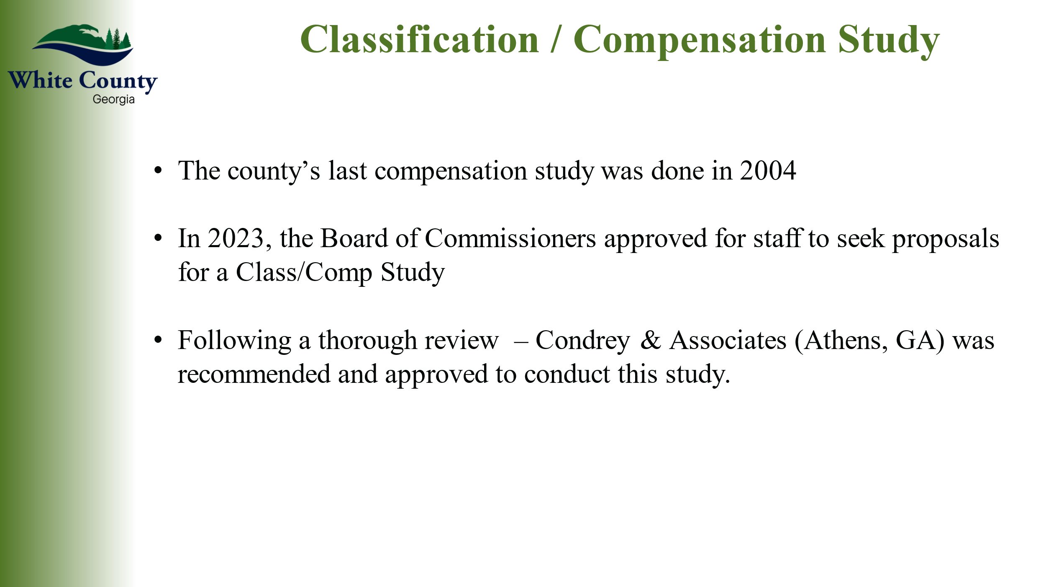
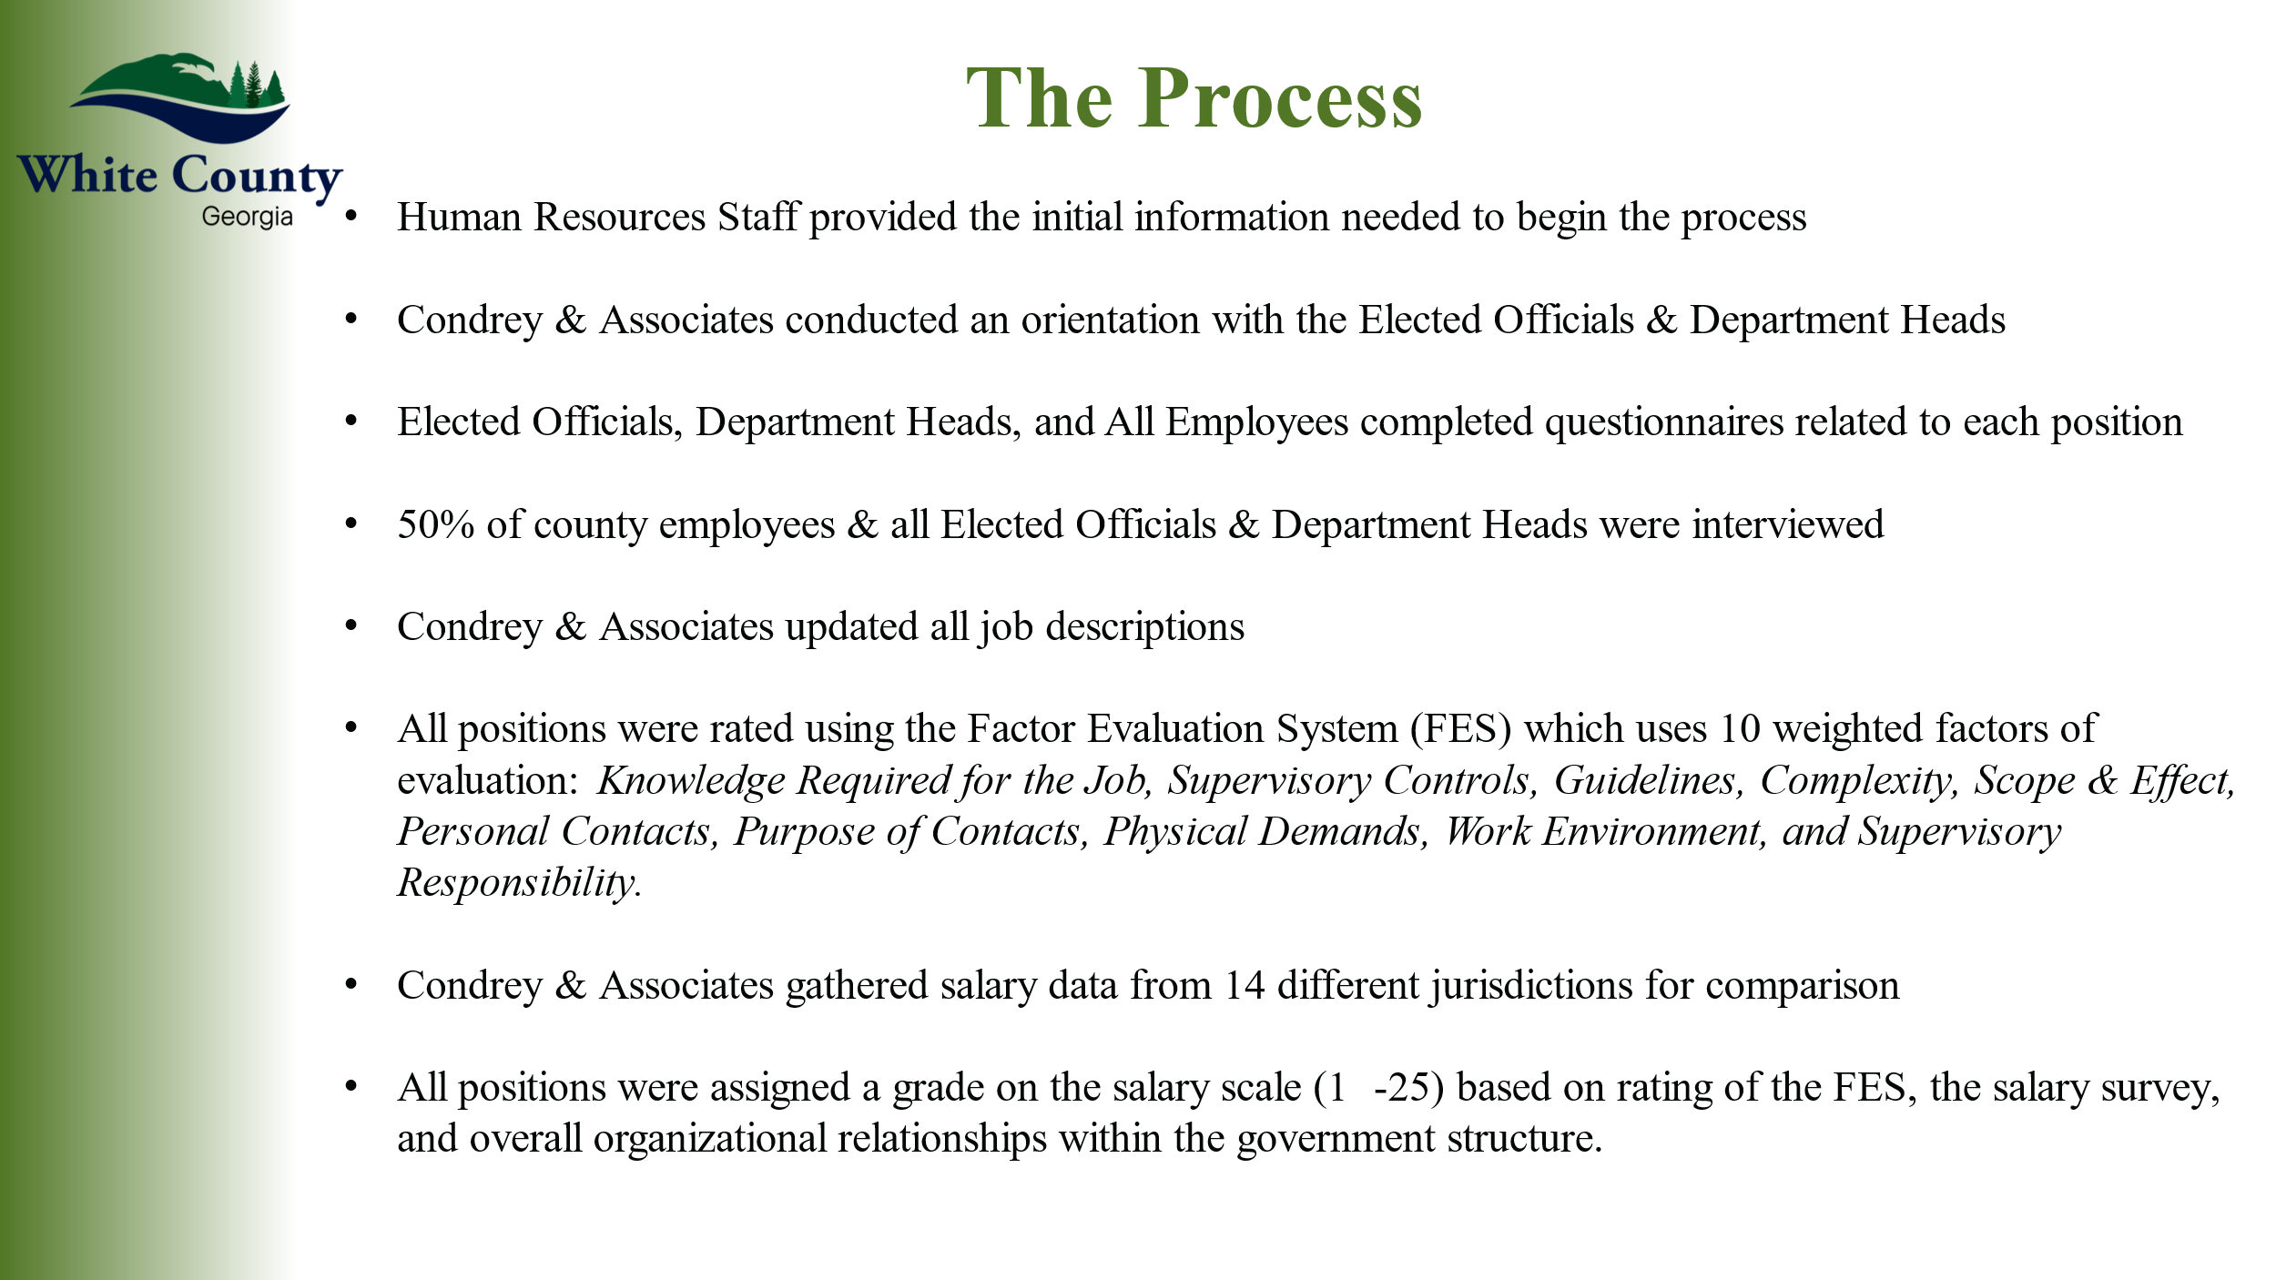
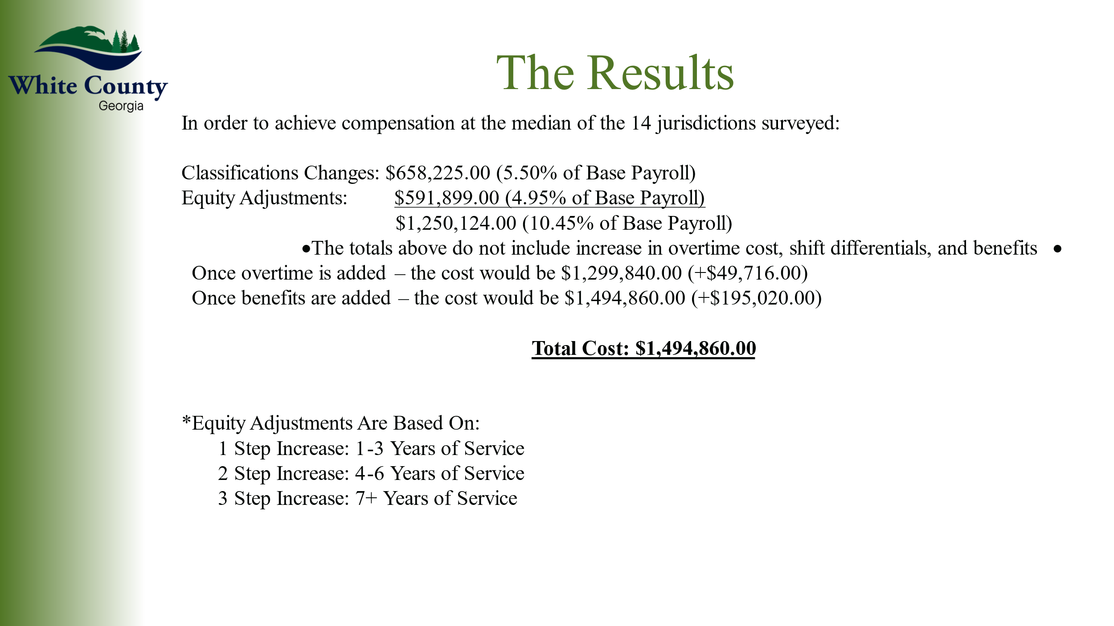
There was a consensus of the Board that the consideration of the 2023-2024 Classification Compensation Study conducted by Condrey & Associates would be placed on the April 1, 2024 Regular Meeting agenda. Chairman Turner stated that he was willing to consider approving implementation of this study if the cost of implementation would not require an increase in the county 2024 millage rate.
Commissioner Goodger advised the Board that he was researching possible funding for the library construction project through Federal Congressional Directed Spending of U.S. Senator Ossoff’s Office. He advised that he would be bringing this before the Board at the April 1, 2024 meeting.
Commissioner Nix reminded everyone that the federal government owns 50% of the property in White County for which the county does not receive property taxes.
Chairman Turner announced that Ms. Jodi Ligon would be leaving employment with White County at the end of March. The entire Board expressed their appreciation to Ms. Ligon for her dedication to White County and for the excellent work she has done during her employment.
Upon a motion made by Commissioner Holcomb, seconded by Commission Goodger there was a unanimous vote to adjourn the meeting.
Minutes of the March 25, 2024 Work Session & Called Meeting were approved as stated this 1st day of April, 2024.
WHITE COUNTY BOARD OF COMMISSIONERS
s/Travis C. Turner
Travis Turner, Chairman
s/Terry D. Goodger
Terry Goodger, District 1
s/Lyn Holcomb
Lyn Holcomb, District 2
s/Edwin Nix
Edwin Nix, District 3
s/Craig Bryant
Craig Bryant, District 4
s/Shanda Murphy
Shanda Murphy, County Clerk

